‘const’ is used to declare constants but ‘let’ is used to declare variables whose values will change.

In Javascript we can use Template Literals to define a string and directly insert variables inside the string without having to use the append (+) keyword.

E.g. -> let str1= “My name is ”+name+” and my age is ”+age+”.”;   
Now using Template Literals,  
let str2= `My name is ${name} and my age is ${age}`;

The Backtics(``) is used to define a Template Literals and ${} is used to place the variables and insert the values at runtime. Inside the curly braces we can also write expressions or any javascript for that matter.

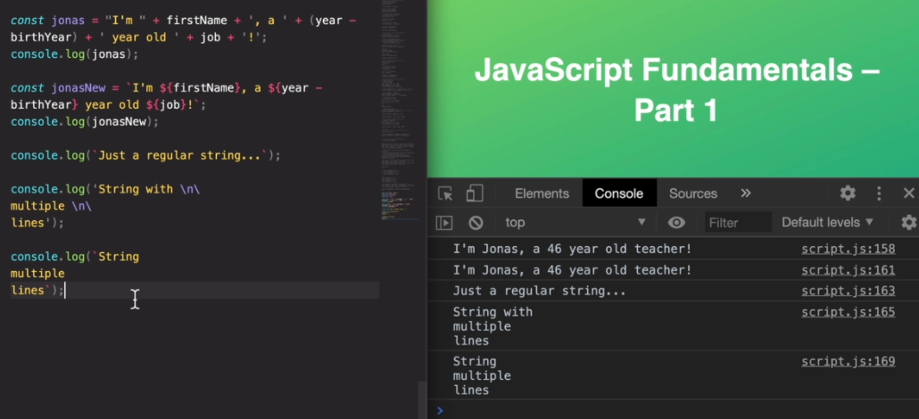

Type Conversion :

For Implicit type conversion,  
to convert String to Number :  
const inputYear = “1998”;  
const year = Number(year);  
console.log(year+23);

>>2021  
 Number()->this function returns the number type values.

Number(“sayak”) -> NaN (Not a Number)

Type Coercion :

When javascript automatically converts the values from one type to another it is called Type Coercion.

**the (+) operator triggers the conversion to String while the (-), (*) and (/) operator and all Logical operator triggers the conversion to Number.  
E.g. : ‘’23”+”10”+3 ->23103  
 ‘’23”-”10”-3 -> 10

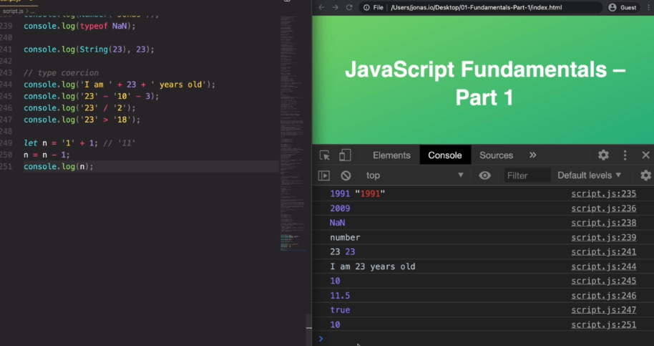

Falsy Values and Truthy Values :

Falsy values are values that are not exactly false but will become false when their type is converted to Boolean type.  
there are 5 falsy values in javascript : 0, “”, undefined, null, NaN

Boolean() returns the Boolean type of a value.  
Boolean(0) -> false; Boolean(19) -> true

Everything else is a Truthy value.

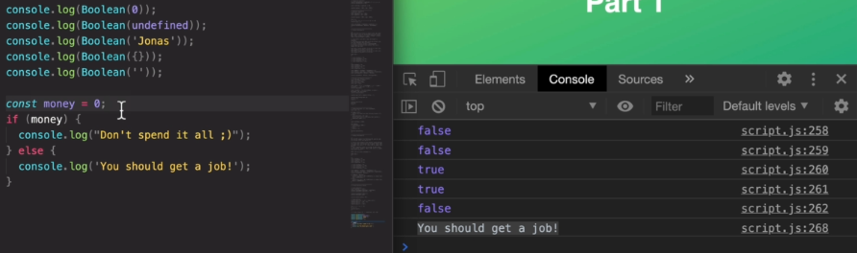

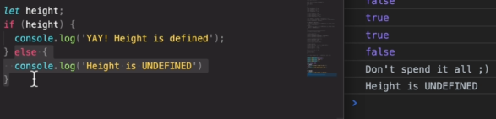

== vs === :

=== is called the Strict Equality operator. Its Strict because it does not perform type coercion( convert the type automatically). So it only returns true the both values are exactly the same i.e. same type and same value.

== is the loose equality operator. Its loose because it performs type coercion. It returns true only by checking the value the type of value can be different, if the types are different it converts the type and then compares.

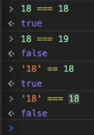

**Switch Statement does a Strict comparison i.e. ===.

Ternary Operator :

const drink = age >= 18 ? 'wine 🍷' : 'water 💧';

console.log(drink);

**Strict Mode** is very useful in javascript it helps us to find bugs in the program more easily. To activate strict mode in javascript we need to mention (‘use strict’;) at be beginning of the code. Using the strict mode logs error in console for many things which normally would not have been logged. E.g. – if any undefined variables is used, if reserved keywords is used.

**Functions :**

In javascript the functions are actually values i.e. it can be a number or a Boolean or a string value and because it is a value we can store it in a variable which actually is the concept of Function Expression.

Function Declaration vs Function Expression :

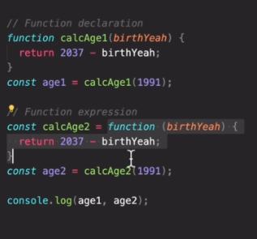

In Function Expression, the expression cannot be called before defining it.

Arrow Functions :

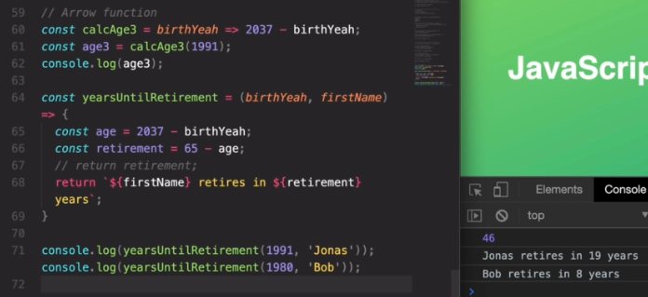

**Array:**

Two ways of initializing array ->

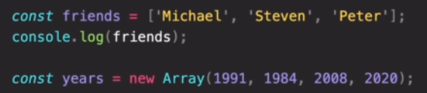

In javascript, arrays can hold values of different types, it is because in an array in each index javascript simply expects an expression not a value of a specific type.

Input :   
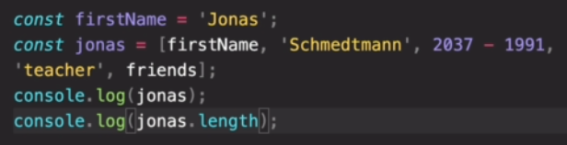

Output :  
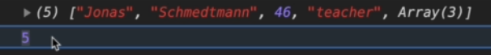

**in the example ‘friends’ is an another array

Basic Methods in Array :

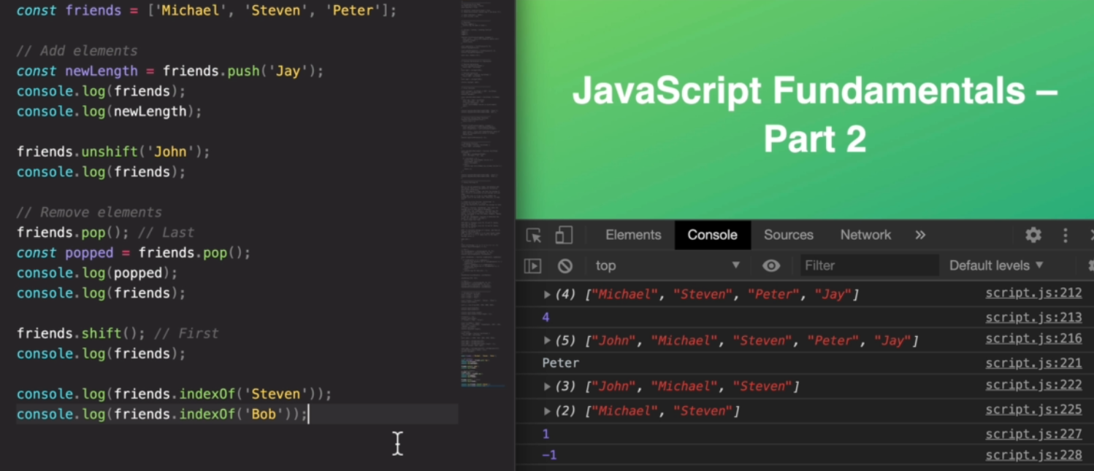

**Objects in javascript :**

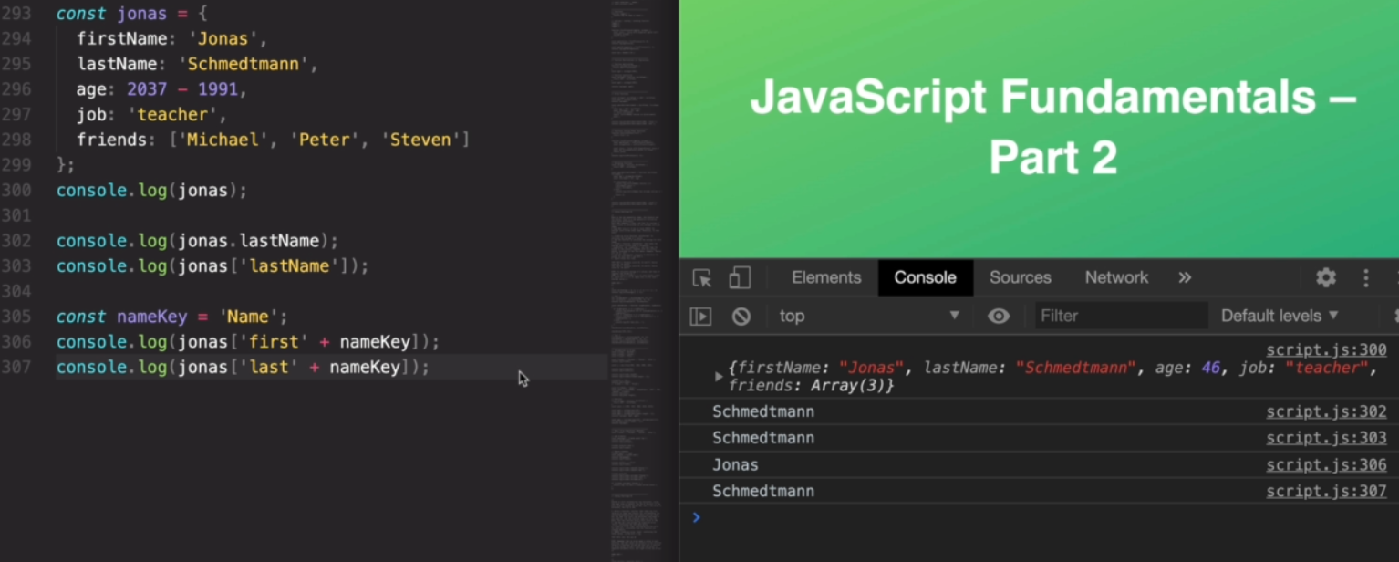

Use of ‘this’ keyword :

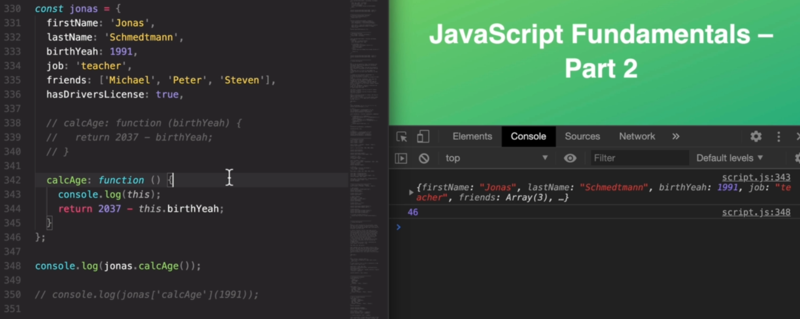

DOM Manipulation : DOM (Document Object Model) is a structured representation of HTML documents. DOM allows

Javascript to access HTML elements and styles to manipulate them. It is the connection between HTML documents and javascript codes. The DOM is automatically created by the browser as soon as the HTML page loads and its stored in a tree like structure as shown below.

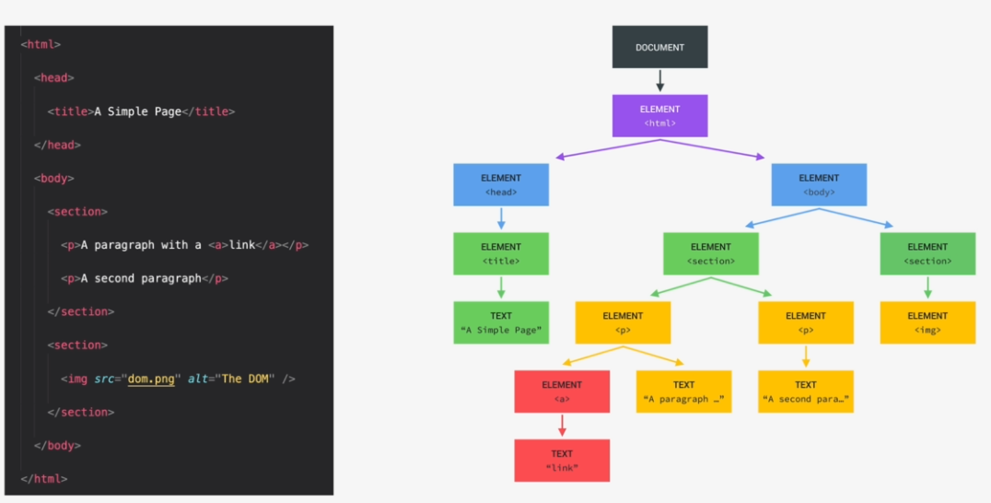

For each element in the HTML there is an element node in the DOM tree and each node is accessible by using javascript. The DOM always starts with document object at the very top and it is a special object that we have access to in javascript, this object serves as an entry point into the DOM. Whatever is there in the HTML document must be there in the DOM, the DOM is the complete representation of the HTML documentation.

DOM and DOM methods are a part of WEB APIs, it is like a library that the browser implement which we can access from our javascript code.

**Different DOM Methods :**

1. To select an input element with class name we need to use the ‘value’ method :

**<input type="number" class="guess" /> : Number(document.querySelector('.guess').value);**

**Number() is used to convert the string type to number type.

1. To select text element with class name we need to use the ‘textContent’ method :

**<p class="message">Start guessing...</p> : document.querySelector('.message').textContent**

1. The addEventListener() method attaches an event handler to the specified element.

**<button class="check">Check!</button> : document.querySelector('.check').addEventListener('click', function(){**

**gameStart()});**

**The ‘event’ mentioned is ‘click’, so whenever there is a click event triggered on this button the adjacent function is executed.

Button can also have more than one class names like <button class="btn check">Check!</button> Here we can use either of the class name i.e both document.querySelector(".check")…. Or document.querySelector(".btn").. works here.

1. When multiple buttons have the same functionality then we can assign the same class names to those buttons. To manipulate multiple elements with the same class name we need to use **document.querySelectorAll(‘.classname’)**, this function will return a NodeList which is similar to an array containing all the selected elements. To manipulate the different selected elements we need to iterate through the NodeList.

E.g. –

HTML Elements with same class name

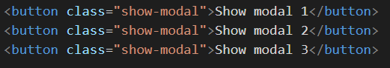

Js to select those elements

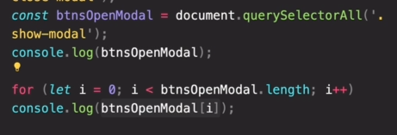

How the NodeList looks like

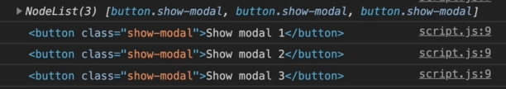

If we use the normal document.querySelector() method with a selector (i.e. class in this case) which matches multiple elements then only get the first one will get selected.

1. In javascript we manipulate the style of different elements by attaching or detaching class which defines a set of styles. For attaching or detaching styles we use **classList.add(‘classname’)** or **classList.remove(‘classname’)**. We can add or remove multiple class at a time from an element like **document.querySelector(‘.classname).classList.add(‘classname1’,’classname2’)**

We can also check if a particular classis associated with the element or not by using **element.classList.contains('className')**

1. **How to respond to Keyboard events** - Keyboard events are global events because they don’t happen on one specific element, to listen to keyboard events we need to use addEventListener(). For keyboard events we listen for it on the whole document i.e. we use document.addEventListner(). So by using the addEventListner() on the document we are basically listening for events everywhere, so no matter where the specified event happens on the page it will trigger the event handler.

**document.addEventListener('keydown', function (event) {**

**console.log(‘A key was pressed’)**

**});**

So this function specifies that whenever a key is pressed anywhere on the screen the specified function will be executed. Whenever a key is pressed a ‘keydown’ event is generated for which our handler function is waiting for to happen. In order to react to only a particular key we need to know which key is pressed, to do so we need to get the event object which is created when the Listener was triggered. To get the event object we just need to pass a variable in the function which is associated to the addEventListner. So when this event occurs Js will call this function with the event object as an argument.

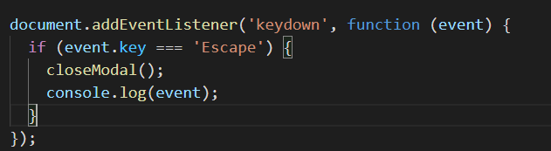  
 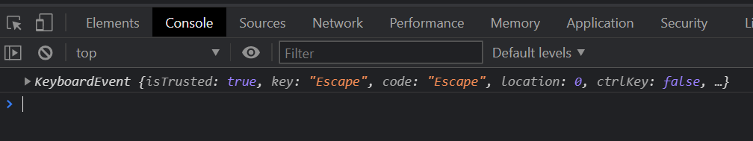

In this scenario when the Escape key is pressed an object is generated by Js containing all the properties for that event.

**Theory :**

Javascript engine – In simple terms a Js Engine is a program that executes Js code. E.g.- Chrome uses V8 Engine as a Js Engine.

Js Engine consist of two components - 1: Call stack 2: Heap

Call Stack is actually where the code is executed using execution context (<https://www.javascripttutorial.net/javascript-execution-context/>).

**Heap** is the unstructured memory pool which stores all the objects that our application needs.

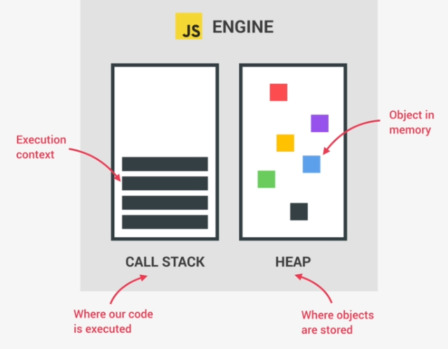

**Compilation vs. Interpretation**

Main objective of Compilation/Interpretation is that it converts the Source Code to Machine Code or converts high Level Language to Low Level Language.

**In Compilation** the entire code is converted into machine code at once and then it is written on a portable file (binary file) that can be executed by any computer. So in compilation 2 steps are involved to run a program : first is compilation where the machine code is generated , second is execution after which the program runs.

In normal scenerio the execution generally occurs way after the code is converted to machine code.

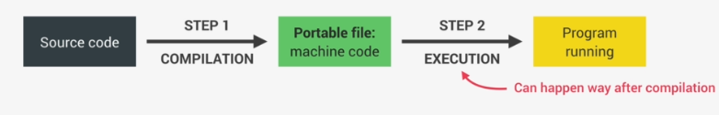

**In Interpretation** there is an interpreter involved which runs through the source code and executes it line by line. The code is read, converted and executed all at the same time; because of which, the code which is interpreted take a lot to time to execute.

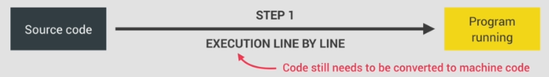

Modern Javascript Engine is a mix b/w interpretation and compilation which is called **JIT ( Just In Time ) Compilation**. In this approach the entire code is converted into machine code at once and then executes it right away, so we still have the 2 steps of regular ahead of time Compilation approach but here the portable file is not generated and execution happens immediately after compilation.

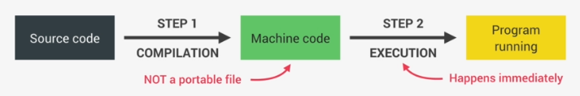

When a piece of Js code enters the Js Engine the first step is to Parse the code i.e. to read the code. During Parsing the code is parsed into a data structure called AST (Abstract Syntax Tree), in this step syntax errors are checked. During Compilation the resulting AST is used to generate the Machine code and this Machine code after compilation gets executed immediately (execution happens in Js Engine inside Call Stack).

Modern Js have some optimization strategies – during first run the machine code that is generated is unoptimized and this unoptimized version of the machine code is executed so that time required is very less, then in background this code is Optimized and re-compiled continuously and all these is done while the program is already in running state. After each optimization the unoptimized code is simply swapped for the new optimized code without stopping the execution.

This Parsing, Compilation, Optimization happens in some special threads inside Js Engine which are not accessible i.e. completely separate from the main thread.

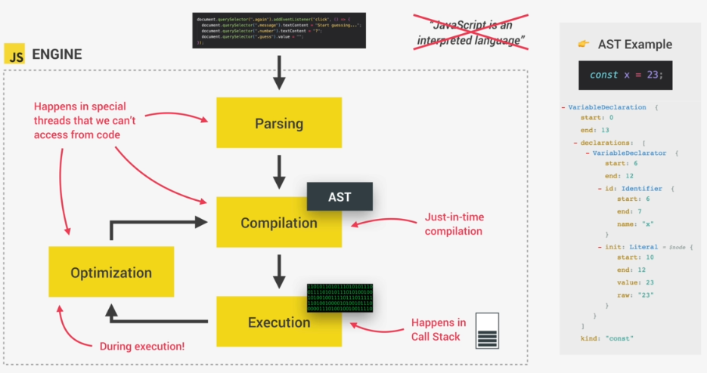

**Javascript Runtime (Browser)**

Js Runtime is like a container which consist of all the things we need to run Js code. The Js Runtime consist of the Js Engine, the WEB APIs (which includes the DOM, Timers etc., web apis are functionality that are provided to the Js Engine but they are not part of the Js Engine, Js gets access to these APIs through the Global Window object ), the Callback Queue (this is a data structure that contains all the callback functions that are ready to be executed, for example we attach event handler function to DOM elements to react to a certain event, these event handler functions are also called callback functions i.e. as the event happens the callback function is called. After the event happens the first thing that happens is that callback function is placed into the Call Queue then when the Call Stack is empty the callback function is passed to the Call Stack so that it gets executed, Event loop takes the callback function from Call Queue and puts them into Call Stack)

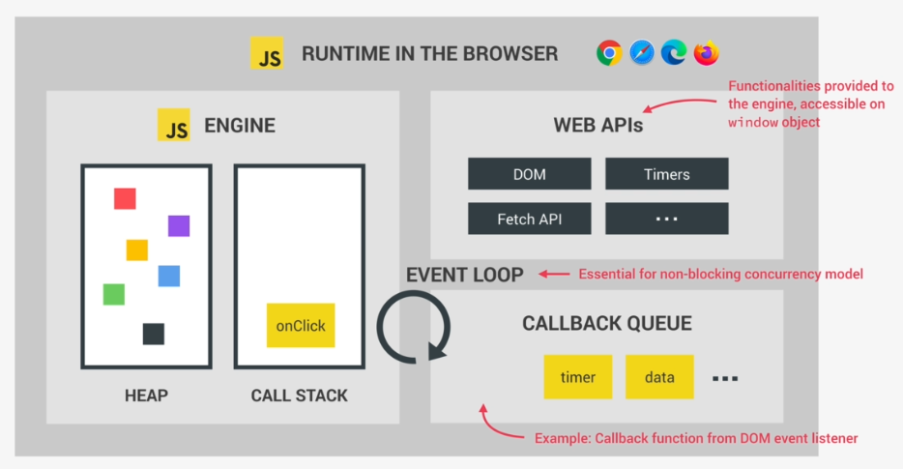

* How the Js code is executed ?

After the Js code is compiled to Machine code and is ready to be executed a Global Execution Context is created for the top-level code (top level code refers to the lines of code which are not within a function ) and is executed.

So at the beginning only the code that is outside any function is executed and code which is inside the function is only executed when that function is called.

* What is Execution Context ?

The execution context is an abstract concept which is defined by an environment where a piece of Js code is executed. It stores all necessary information for some code to execute.

In any Js project there is only one Global Execution context, it is always there as the default context and it is where top level code executes.

After the top level code starts getting executed the code written within function also starts to get executed in the order it is called. For each and every function call a new Execution Context gets created containing all the information necessary to run that function.

All of these Execution Context together make the call stack.

Execution Contexts consists of –

1: Variable environment – it consist of all the variables and function decelerations and there is also a special **argument object**, this argument object contains all the arguments that were passed in the function parameter of the function to which this execution context belongs to.

2: Scope Chain – functions can also access variables outside the function, this works because of scope chain. The scope chain consist of references to variables that are located outside the function.

3: **this** Keyword

All these are created right before the code execution.

**Execution Context of Arrow Functions does not contain Argument Object or this Keyword.

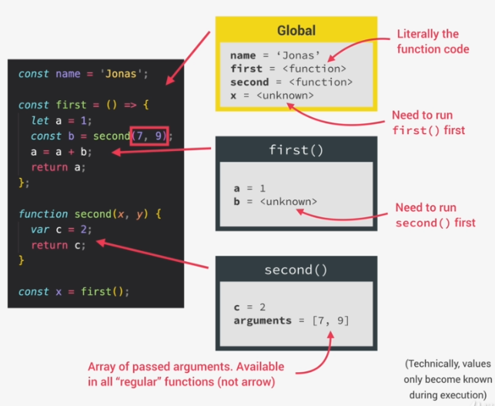

**The Call Stack :**

Usually in a Js code a no. of Execution context gets created for a no. of functions, in order to keep track of the order in which the functions were called the Call Stack is used. Call Stack is where all the execution context gets stacked on top of each other on the order in which it was called (LIFO). Call Stack also keeps track of where it is in terms of execution.

The order in which the functions are called in the same order the execution context also gets stacked on top of each other. They follow LIFO i.e. the last execution context will get executed first and after execution it is the first one to be removed.

The Global Execution Context is the first one to be pushed into the call stack (which contains the top-level code), as the top level code gets executed if any function call is made an Execution context for that function is created and pushed to stack where it is placed on top if the existing execution context. After this the newly created execution context gets executed and the execution of the previous execution context gets paused, only after the current Execution context gets executed completely the control returns to the previous execution context to the same point where it got paused (in this case the Global Execution Context) after removing the one which got completed.

**Only one execution context gets executed at a time because Js has only one thread for execution. **Javascript** is a **single threaded** language. This means it has one call stack and one memory heap.

**Scope Chain:**

Scope – It is the space or environment in which a certain variable is declared. There are 3 different types of scope : Global scope, Function scope, Block scope.

Scope of a variable – it is the region of our code in which a certain variable can be accessed.

Types of Scope –

Global Scope – the scope of the variables or functions ( functions are just values that are stored in variables ) that are declared outside of any function or block are called Global Scope. The variables declared in global Scope are accessible everywhere ( inside every functions and blocks ) in the program.

Function Scope – each and every function creates a scope and the variables declared inside that scope are said to have function scope/local scope. The variables are accessible only inside the function in which it is defined. Generates a *Reference Error* when accessed outside the function.

Block Scope – earlier blocks didn’t had any scope in Js but from ES6 it is added. By block we can define any type of block i.e. block of ‘if’ statement or block of ‘forloop’ statement etc. Variables declared inside the block are only accessible inside the block only.   
However, this only applies to variables declared as ***let*** or ***const***. Only ***let*** and ***const*** variables are restricted to the block in which they were created. If a variable is declared as ***var*** inside a block then that variable will still be accessible outside the block, that is why ***let*** and ***const*** are called ‘block scoped’ and ***var*** is ‘functioned scoped’.

***let*** and ***const*** type variables if declared in global becomes global scoped, if declared withing a function becomes function scoped and if declared within a block becomes blocked scope. Whereas ***var*** type variables works same as let or const when declared globally or inside a function but when declared within a block, it ignores the block and acts as if it is function scoped if the block is within a function or as global scope if the block is declared globally.

**Functions are also block scoped but only in ***strict*** mode.

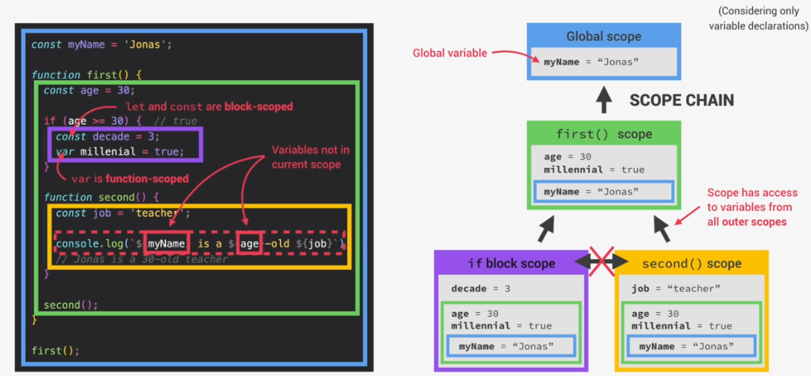

**the ‘*millenial’* variable is of type **var** that is why it is also accessible in the function ‘*second()* as well as *‘scope()’.*

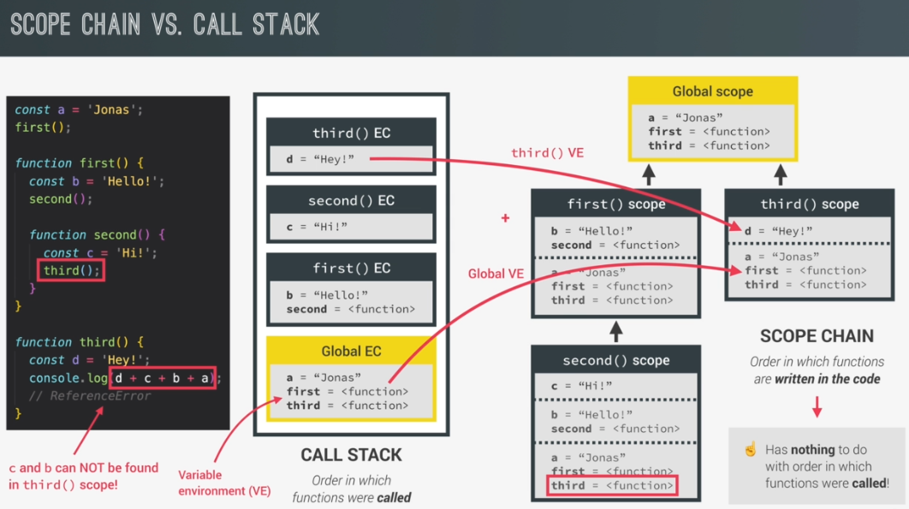

**Scope Chain has nothing to do with the order in which the functions were called i.e. the scope of a variable is only determined by where it is declared (the variable is scoped to the nearest pair of curly braces, only exception is ***var*** type variables).



* How variables are actually created ?

In Js there is a mechanism called **Hoisting** which makessome type ofvariables in the code accessible/usable before they are actually declared. How Hoisting works is that, before execution, the code is scanned for variable declarations and for each variable a new property is created in the variable environment object. This happens during the creation phase of the execution context.

However, hoisting does not work the same for all variable types,

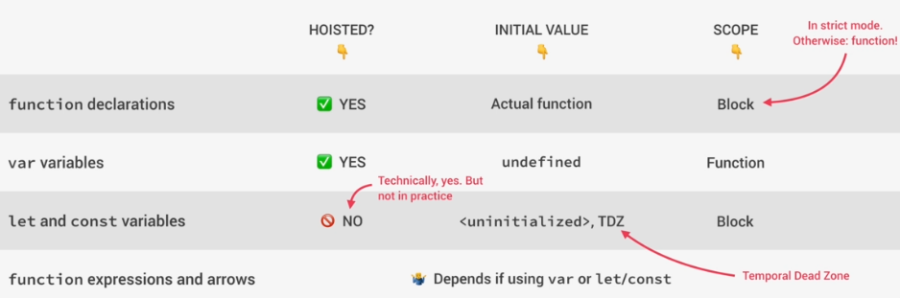

If we try to access ***var*** type variables before declaring or initializing we get the value as ‘*undefined*’ but if we use ***let*** or ***const*** in the same way we will get an error as there are one values available for these variables.

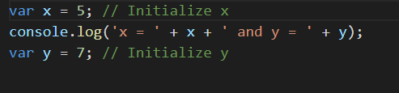 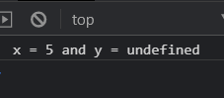

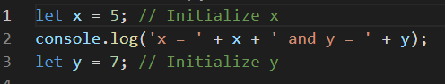 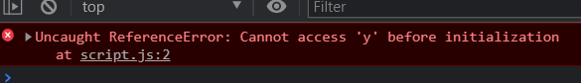

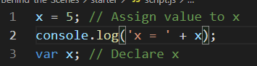 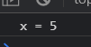

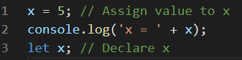 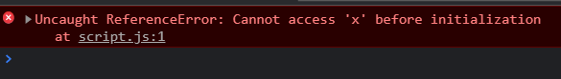

Temporal Dead Zone (TDZ) – it is the region of the scope of a variable in which it is defined but cannot be used in any way i.e. from the nearest open brace to the line where the variable is declared. Each and every ***let*** and ***const*** variable has its own TDZ and the variable is unable only after its TDZ.

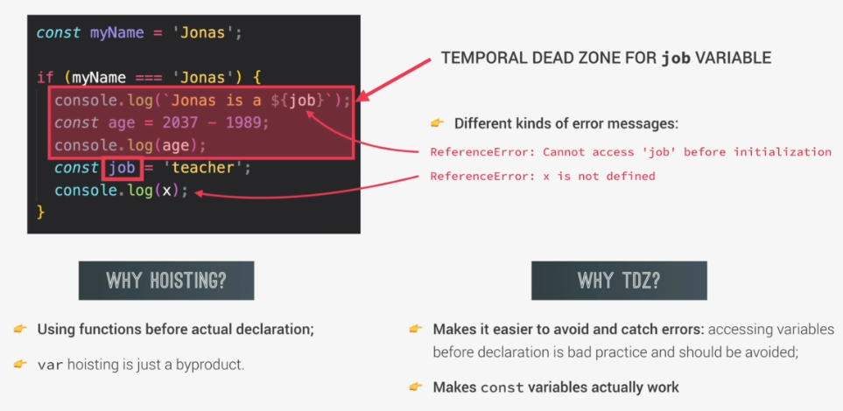

**‘this’ Keyword :**

It is a special variable that is created for every execution context ( same as saying every function ). The ***this*** keyword will always take the value of ( or point to ) the owner of the function in which it is used. Owner refers to anything with which the function is called.

The value of ***this*** keyword is not static. It depends on how the function is called and its value is only assigned when the function is actually called.

A function can be called using 4 different ways –

* Calling function as a method ( i.e. as a function attached to an Object ) : this keyword 🡪 Object that is calling the method
* Simply calling the function ( not attached to any Object) : this keyword 🡪’undefined’ (using strict mode), global object i.e. window object for the browser (not using strict mode)
* The **this** keyword when used in Arrow function will act as the this keyword of the surrounding function/parent function. Arrow functions do not get their this keyword.
* When function is called as an Event Listener then the **this** keyword will point to the DOM Element the event handler ( ‘click’ ) is attached to.

Different Types in Js – Primitive types and Reference Types ( objects )

Primitive types are stored in call stack ( inside execution context )

Reference types are stored in HEAP memory

When a variable is created for **Primitive data types**, Js will create an unique identifier with the variable name then it will allocate a piece of memory having some base address, the value of the variable is stored in that memory and the identifier points to the memory address. These all happens in the call stack where the primitive values are stored.

**In Js the value at a certain memory address is immutable, if a new value is assigned to an identifier a new memory is allocated to store the new value.

When a object is created which is a **Reference data type**, Js will allocate a piece of memory in HEAP having some base address where it will store the value of the object in HEAP memory. But the identifier will be created in Call Stack having same name as object name. The identifier does not directly point to the HEAP memory address where the object is stored but a piece of memory will be allocated which will store the HEAP memory address as the value.

Thus, the piece of memory in call stack has a reference to the piece of memory in the HEAP which holds the object ( ‘me’ ).

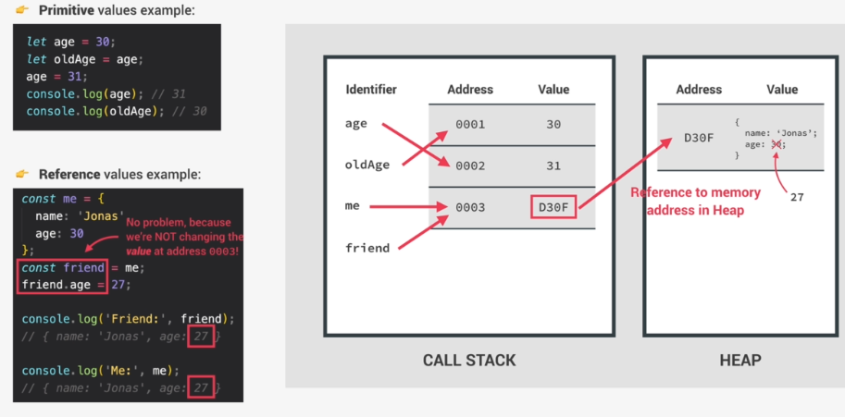

Objects are stored in HEAP not in Call Stack because objects might need a large amount of memory which the call stack may not be able to provide, HEAP memory is like an unlimited memory pool.

Copying Objects –

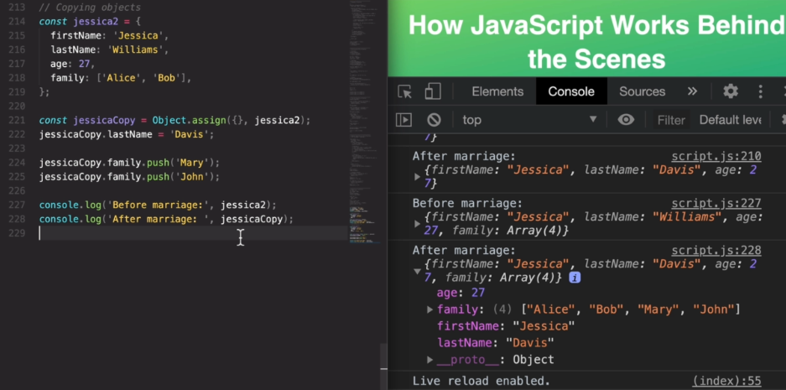

**using Object.assign() only creates a copy of the object in the 1st level i.e. none of the nested objects are copied.

De-structuring of Array :

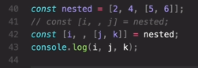 

De-structuring of Objects :

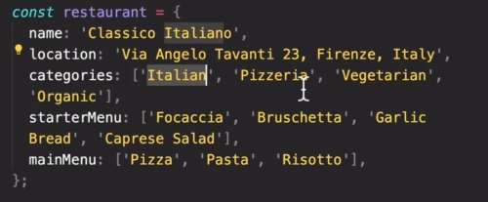

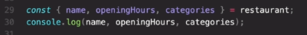 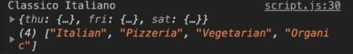

To de-structure the object we use curly braces and also the name of the variable should be exactly same as property name of the object

Spread Operator (…):

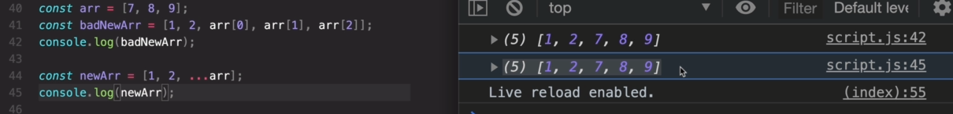

When we need to pass all values of an array we use the spread operator.

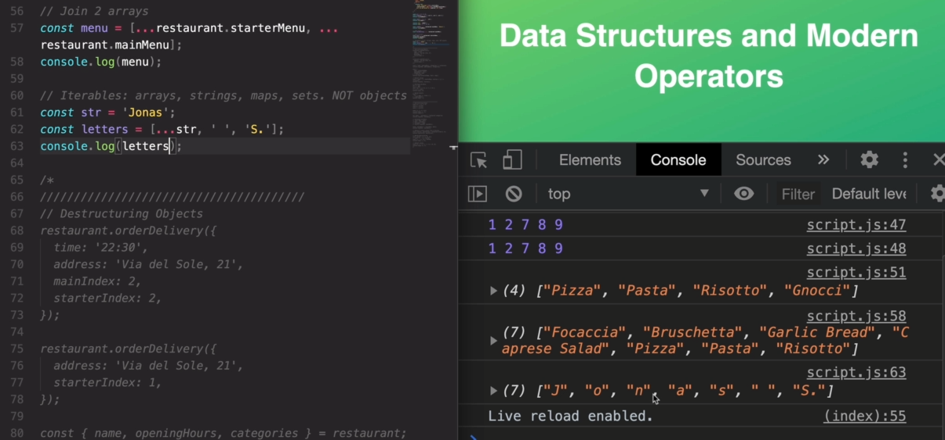

Object.keys() and Object.values():

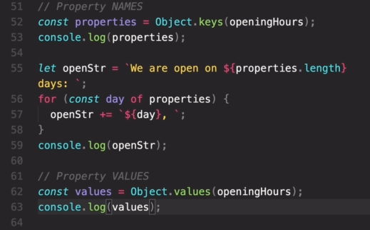 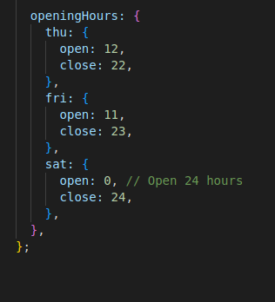

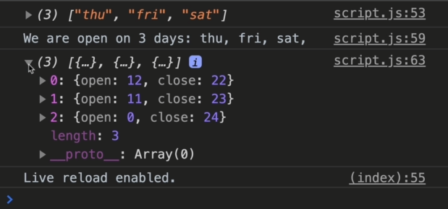

Object.entries():



Entries():

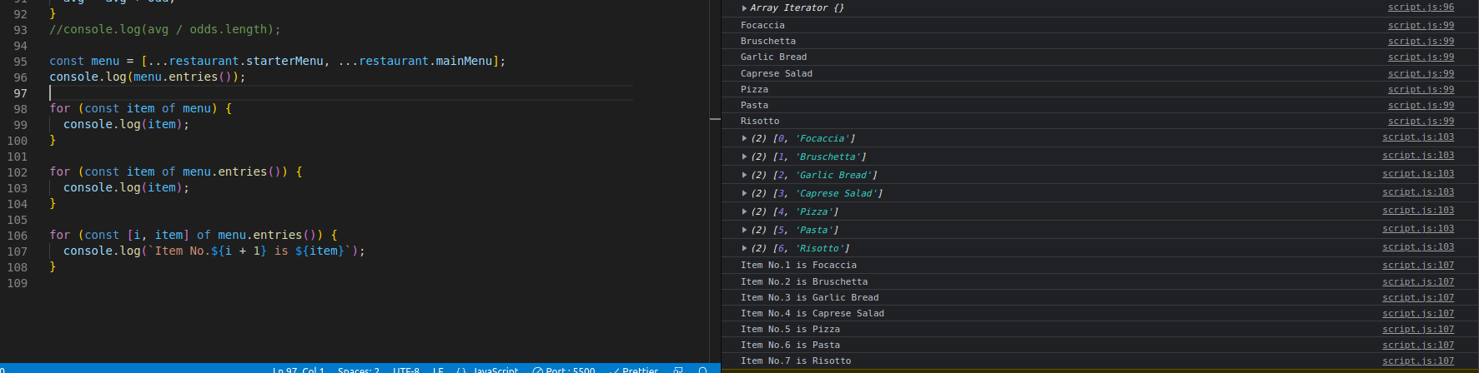

Sets:

A set is a collection of unique values in JS i.e. it can never have duplicates. Set can be initialized as new Set(iterable)



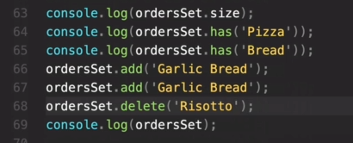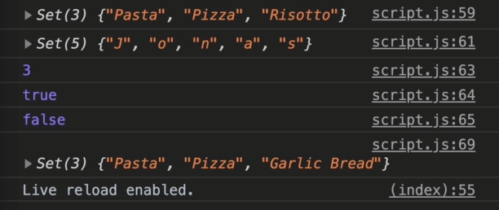

.clear() is used to empty the set.

orderSet[index] does not work because there are no indexes in Set and elements of Set is not in order.

Map:

Map is a data structure in JS to map values to keys. It contains kay-value pares and the key can be of any type.

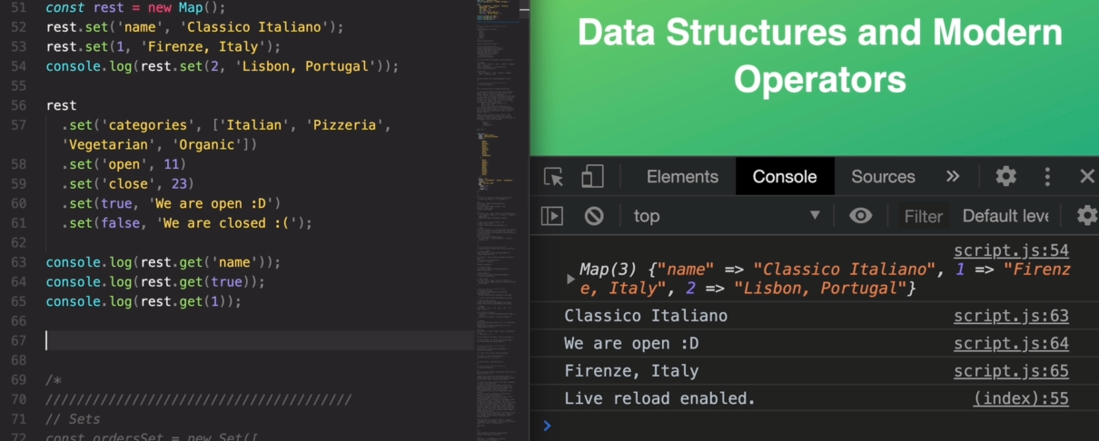

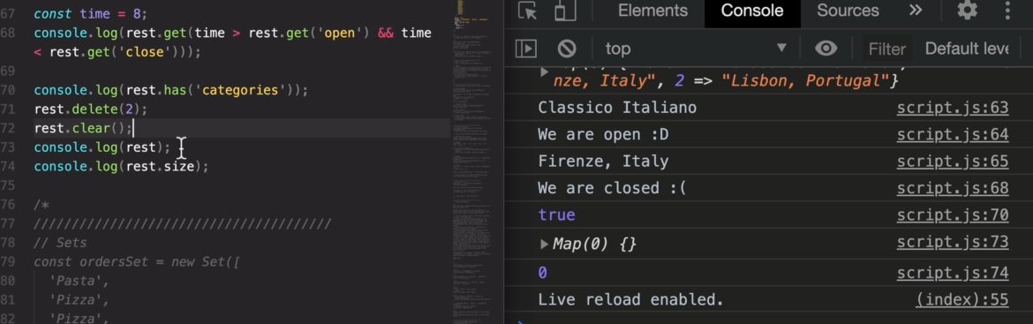

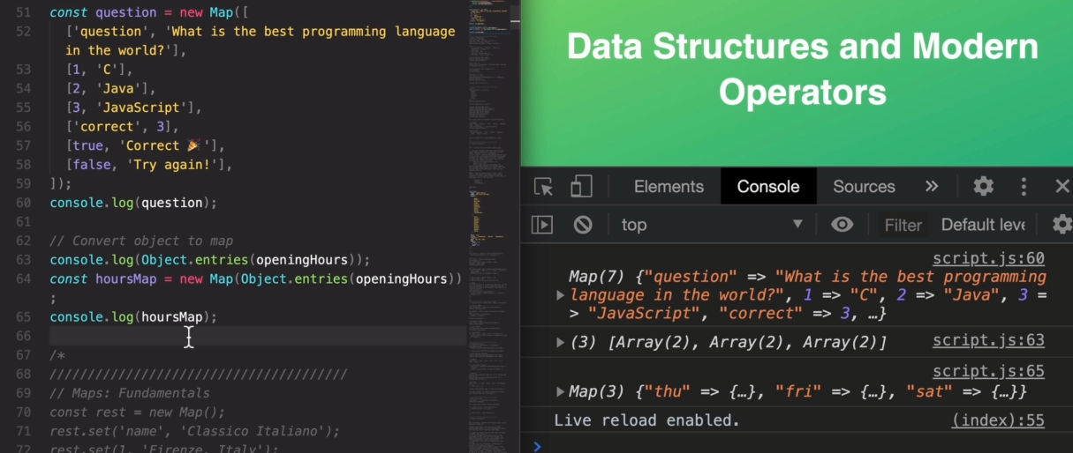

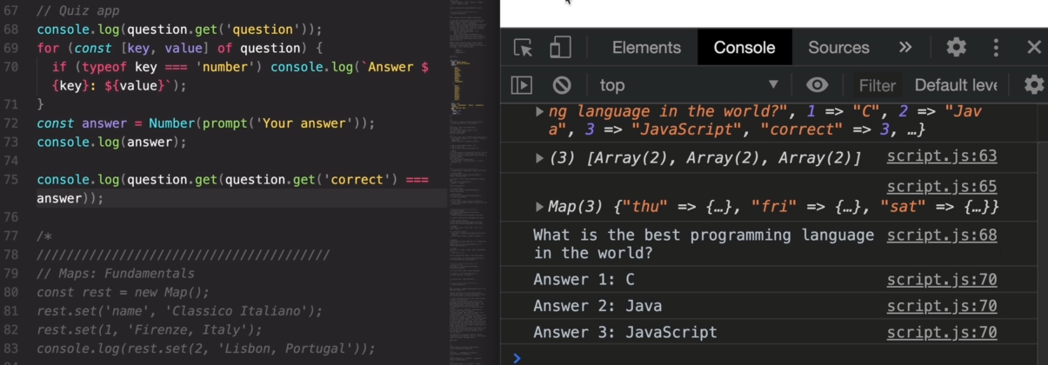

String Methods:

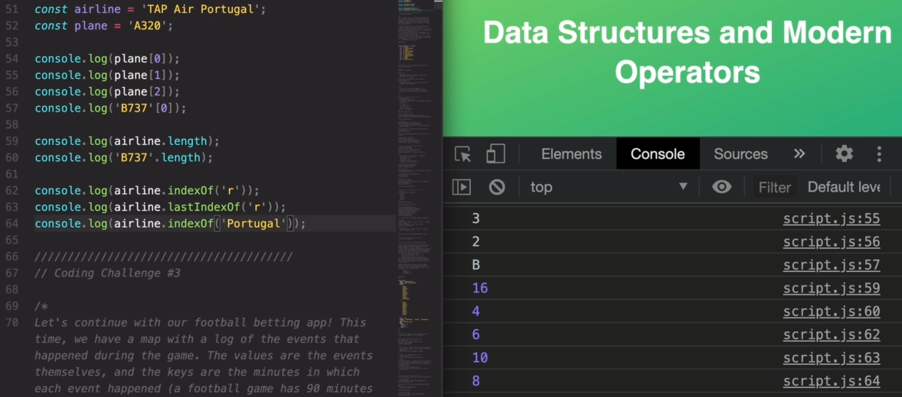

More on JS Functions:

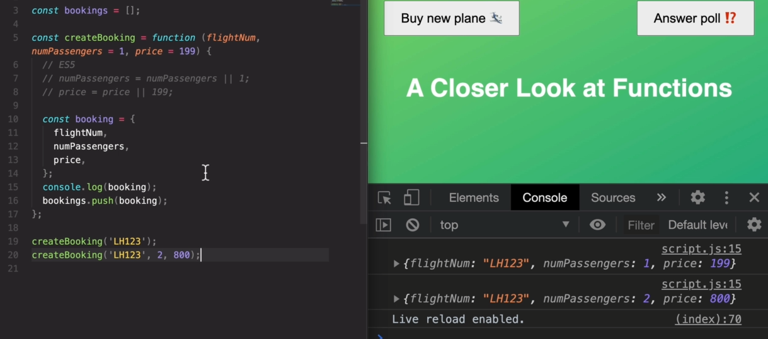

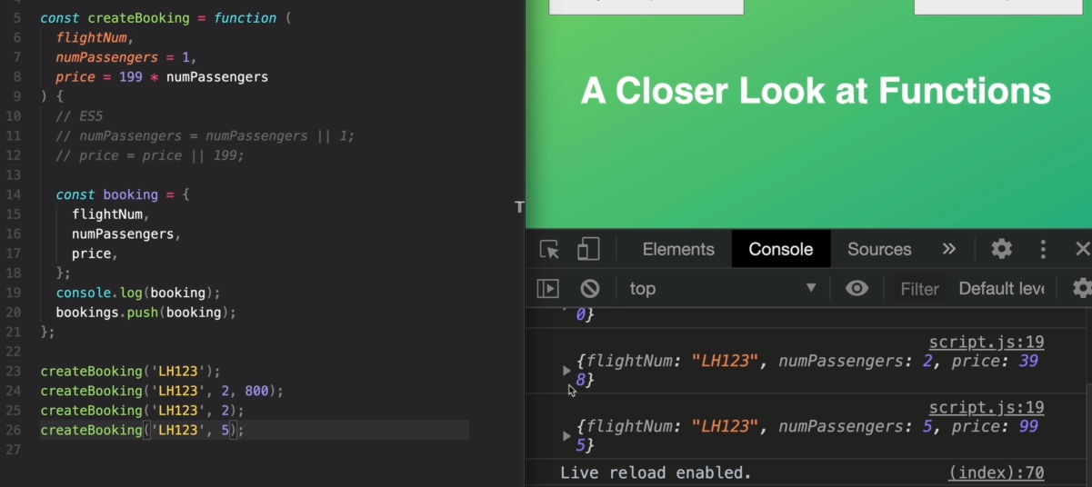

Because ‘flight’ and ‘flightNum’ is a String i.e. a Primitive type variable when checkIn() is called in line 51 a new object of ‘flightNum’ is created which contains the same string value. But for ‘jonas’ Object because it is a reference type variable the ‘passenger’ obj refers to the same obj as ‘jonas’ so changes made in ‘passenger’ reflects in ‘jonas’ also.

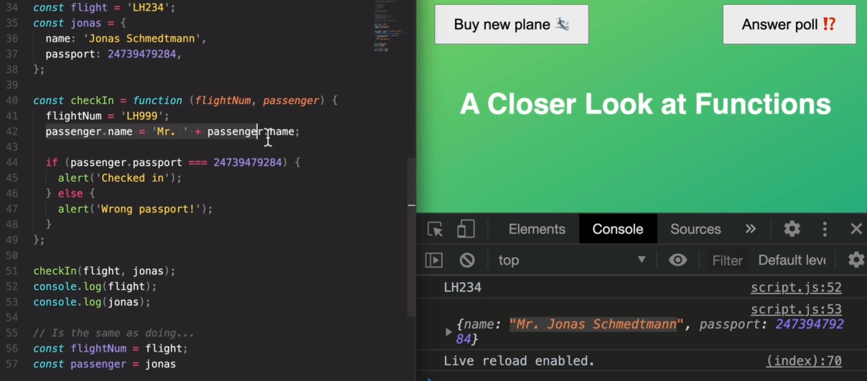

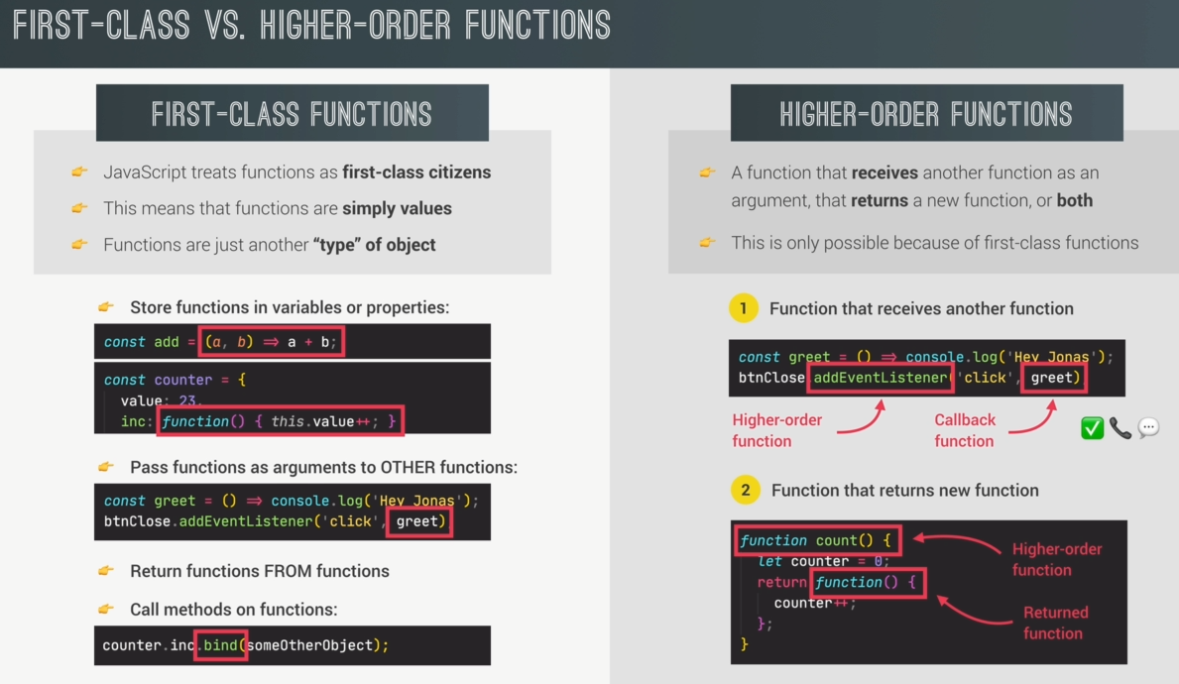

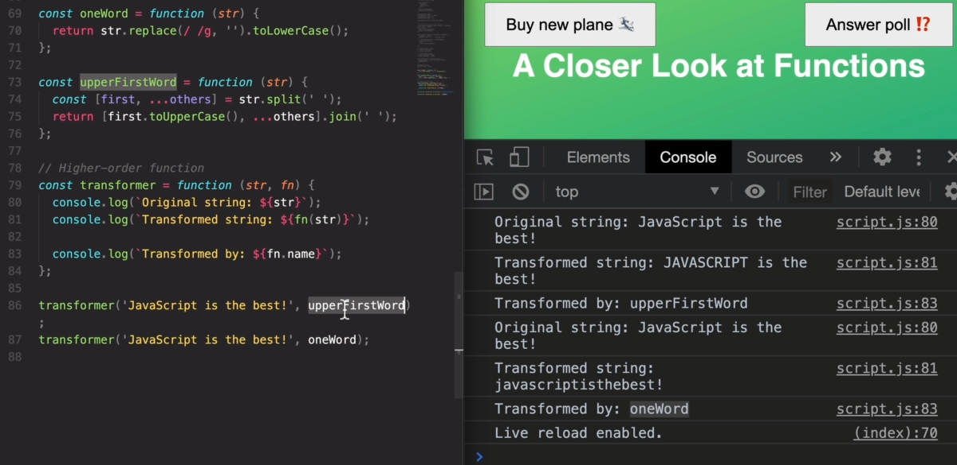

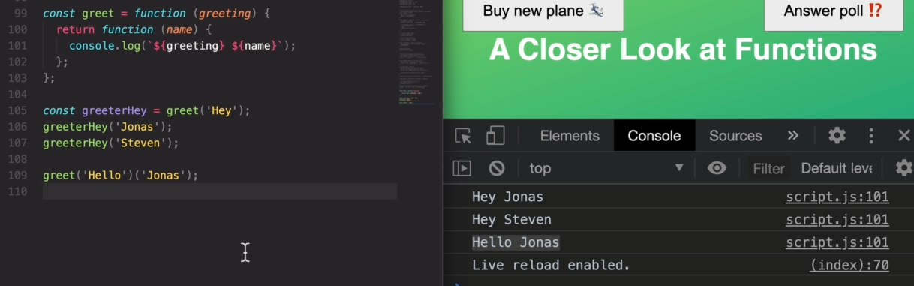

‘this’ keyword:

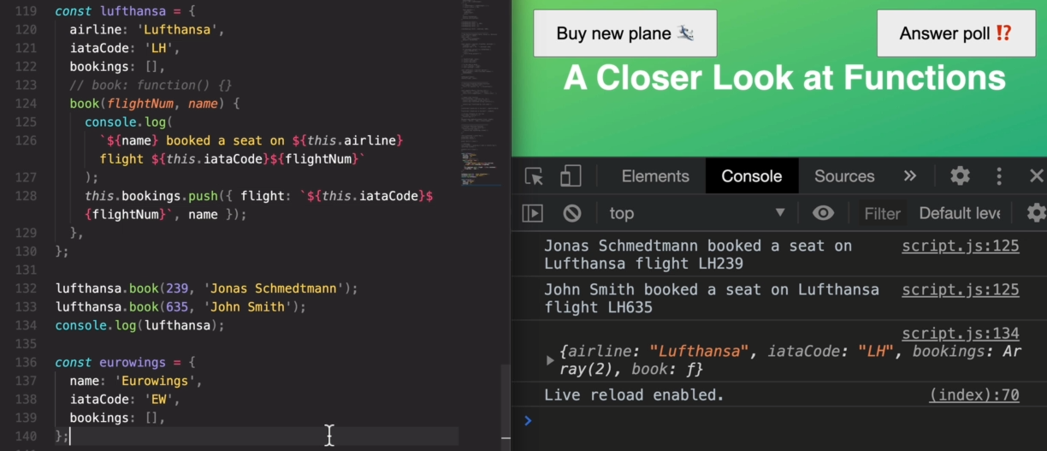

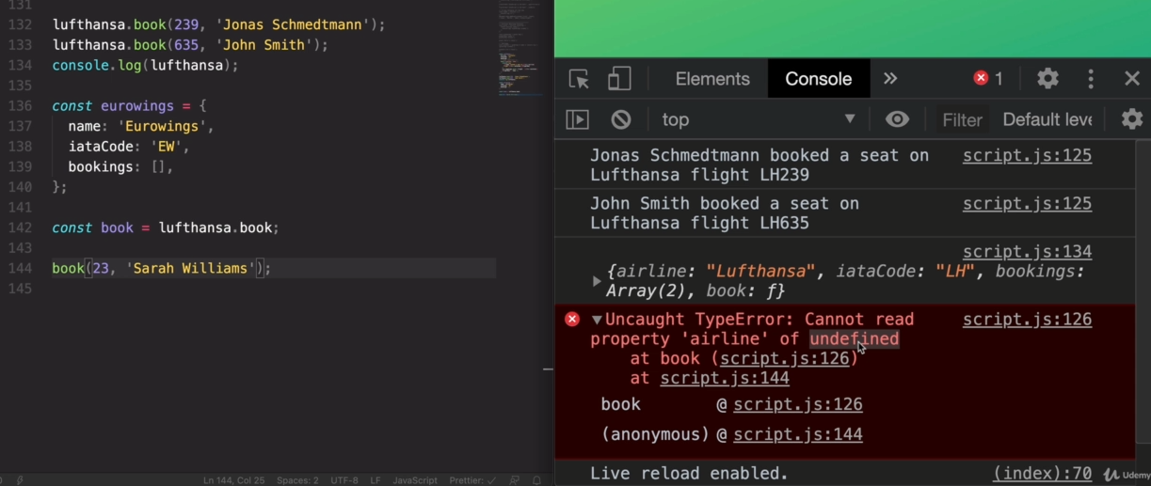

Here we get this error because the ‘book’ function created in line 142 is just a regular function, it is not exactly the ‘lufthansa.book’ function, it is just a copy of that. And as we know the ‘this’ keyword inside a regular function points to UNDEFINED in STRICT mode.

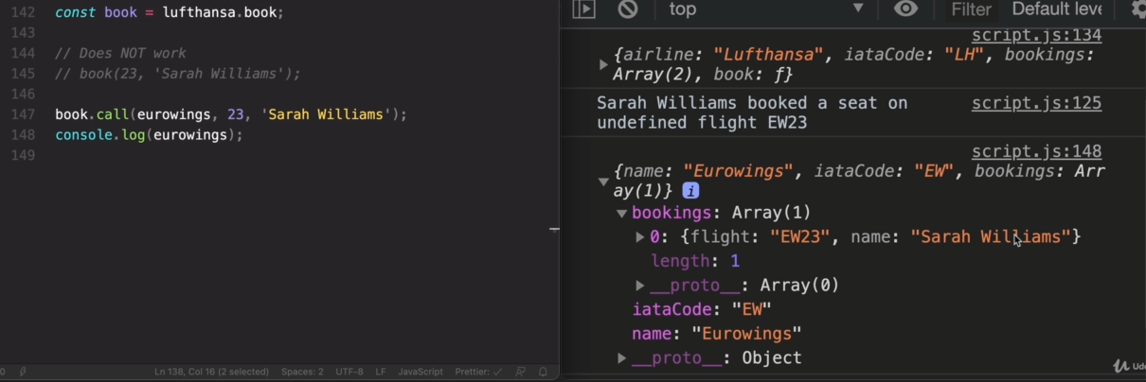

To bypass the above problem we use call(). Here we don’t directly call the ‘book’ function but call book.call() and the call() in turn calls the book() with the ‘this’ keyword set to whatever obj name we pass in the call() which here in line 147 is the ‘eurowings’ obj. The call() allows us to manually and explicitly set the ‘this’ keyword of any function to any object that we want to call.

In Js a function is really just an object and objects can have methods and function can have its functions too.

Bind():

Bind() is used for the same purpose as call() but difference is bind() takes the obj for ‘this’ keyword and returns a new function where the this keyword is already bound.

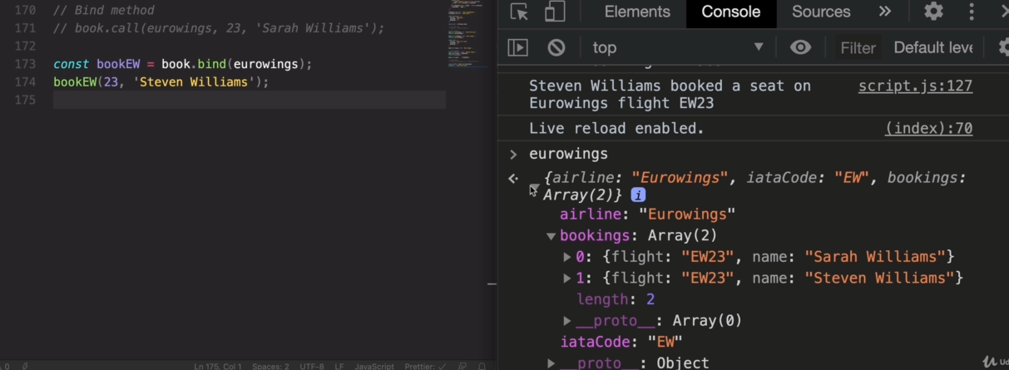

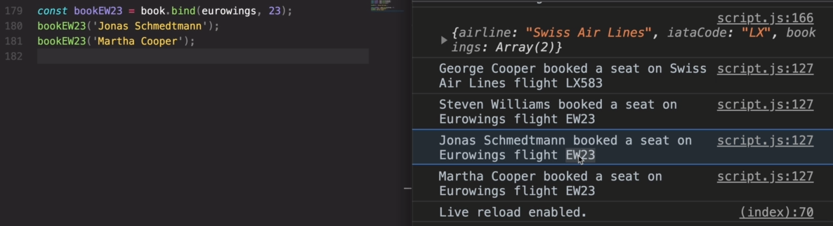

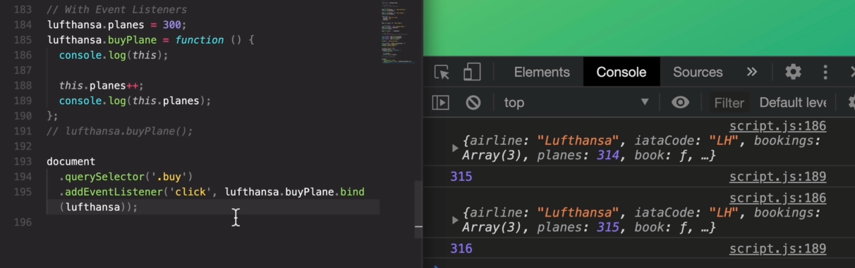

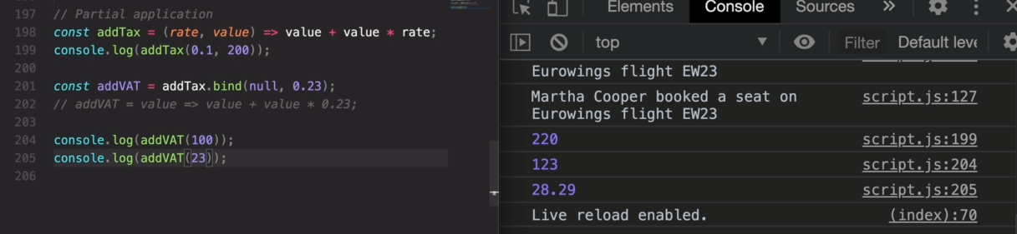

Immediately Invoked Function Expression:

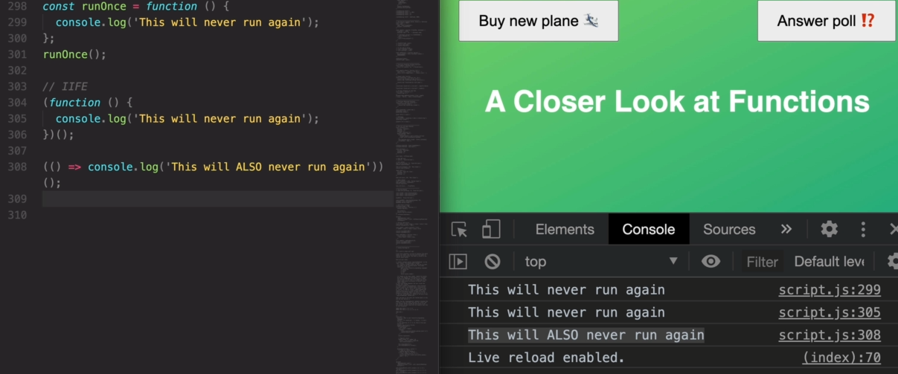the functions in line 304 and 308 are called Immediately Invoked Function Expression because they execute only once and cannot be executed after 1st execution.

What is Closure in Js:

How functions work – in below code when secureBooking() is defined we can say that the Global Execution Context only contains the secureBooking() since it is defined in Global Scope. When secureBooking() is executed a new Execution Context(secureBooking EC) is put on top of the Global Execution Context. Each Execution context has a variable environment which contains all its local variables, in this case it only contains the passengerCount variable set to 0. This variable environment is also the scope of the function and this variable environment also gets access to all the variables in parent scope which is the Global scope in this case.  
After the execution of secureBooking() has completed the secureBooking EC gets removed from the Call Stack.

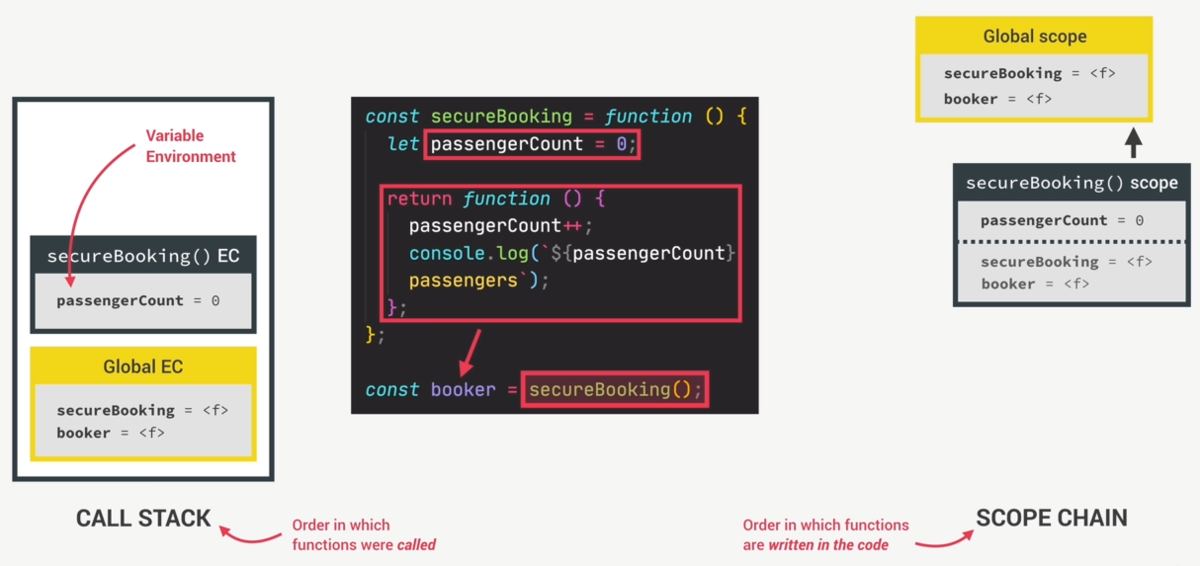

Problem – When we run the booker() a new EC is created (booker() EC) and put on top of the Call Stack. Since the booker() is in the global context only it’s scope is a child scope of the Global scope.

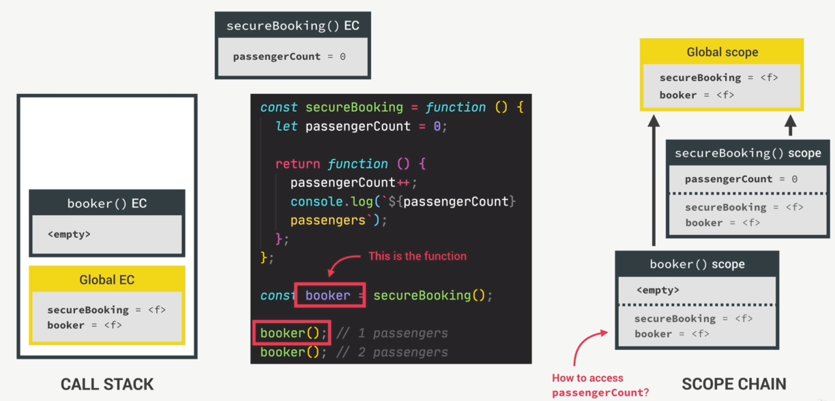  
But how does the booker() assess the passengerCount variable as it is removed from the scope chain.

How it actually works using Closure – Any function always has access to the variable environment of the execution context in which the function was created even after that EC is removed from Call Stack. In the case of booker(), it was created in the Execution Context of secureBooking() (which was removed from stack as its execution was completed) thus the booker() will get access to the variable environment of secureBooking() EC which contains the passengerCount variable and this is how the booker() reads and manipulated the passengerCount variable. This connection of the booker() scope to the variable environment of secureBooking() EC is called CLOSURE.

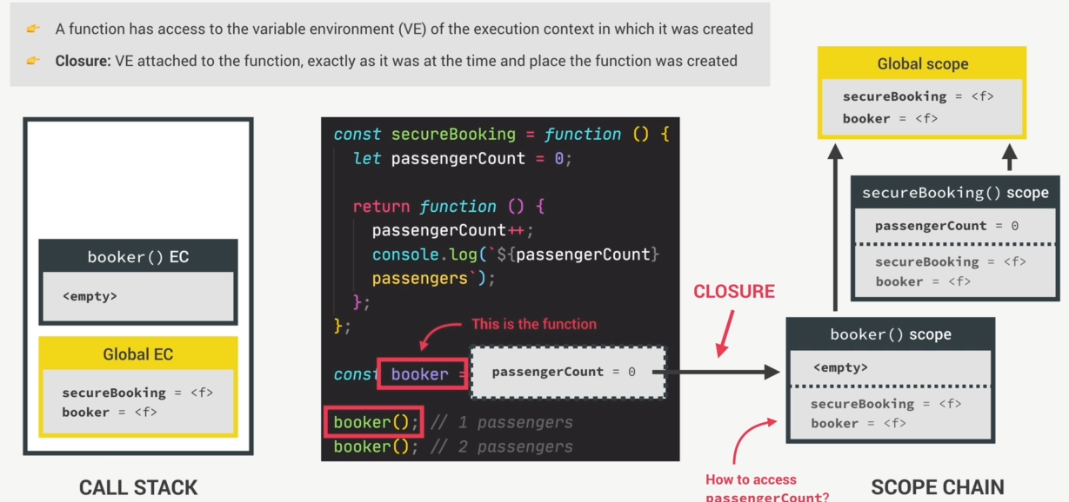

When booker() is called the function attempts to increase the passengerCount variable however this variable is not available in the current scope and so Js will immediately look into the Closure to see if the variable is there and it does this even before looking in the scope chain. If there was a Global passengerCount variable still it would still use the one in Closure. CLOSURE has priority over Scope Chain.



To view Closure in console 🡪 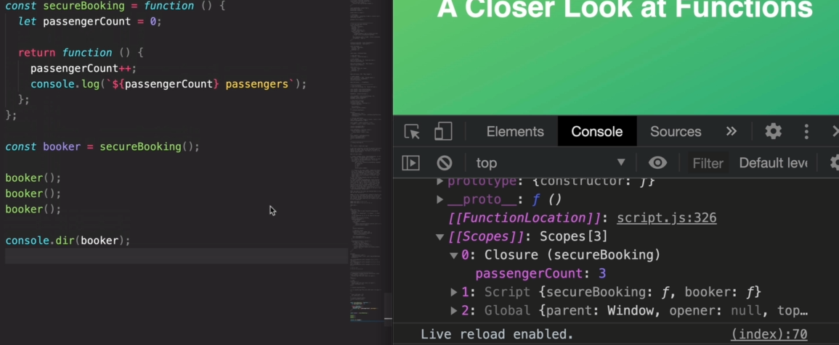

Examples of Closure:

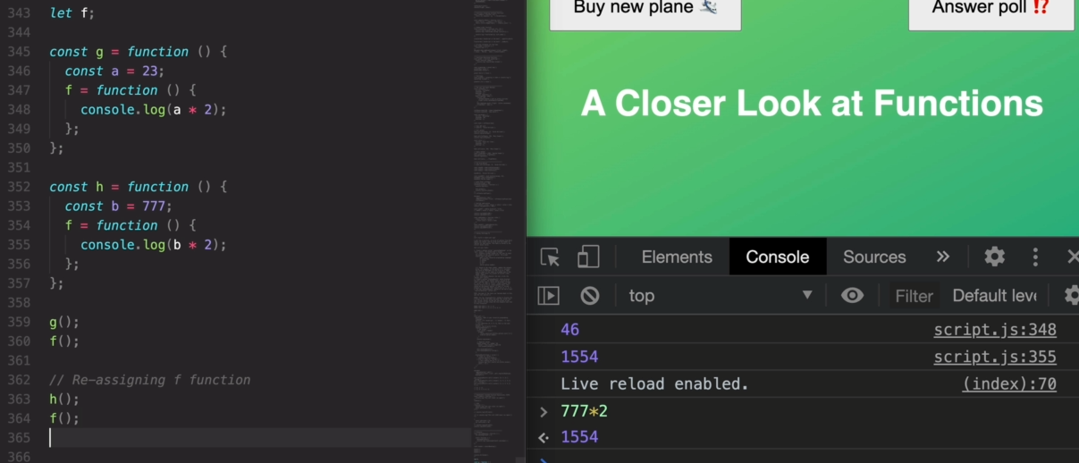

**Array:**

slice():

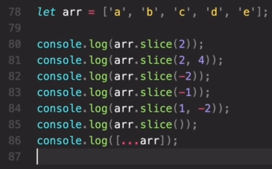 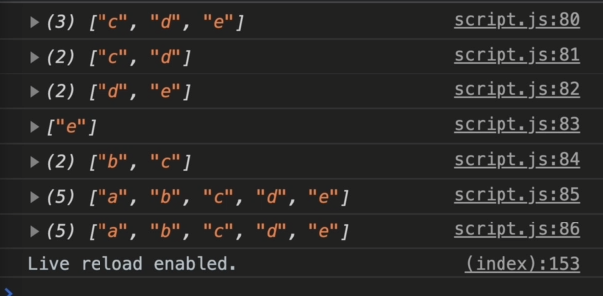

splice(): --mutates the original array

It works almost the same way as slice() but the difference is it actually changes the original array.



In arr.slice(3,2) -- 3 is the position of element from where we want to remove and 2 is the no. of elements we want to remove from position 3.



reverse(): --mutates the original array



concat():



join():



forEach() with arrays:

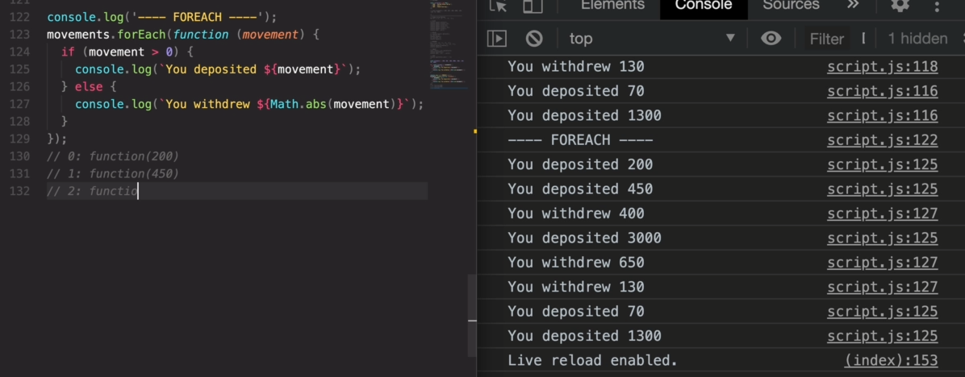

forEach() actually passes the current element of the array, the index and the entire array itself it is looping in respective order in the callBack() –

\*\**continue* and *break* statement does not work in forEach loop instead it always loops over the entire array, to use the *continue* and *break* statement we need to use the *forof* loop

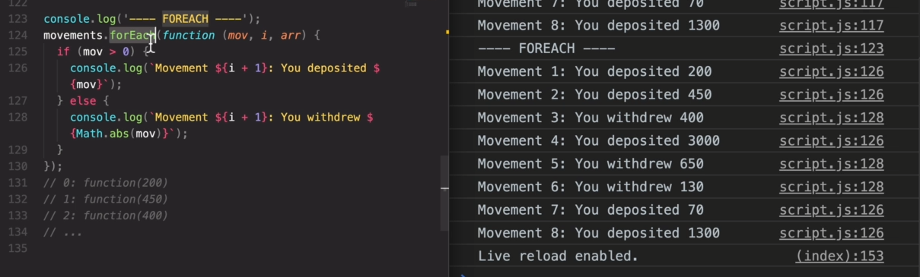

forEach() with map:

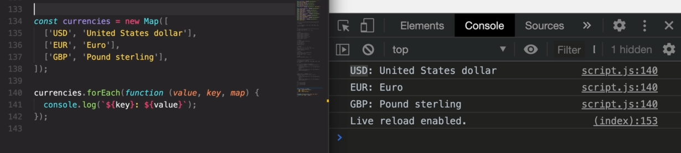

forEach() with sets:

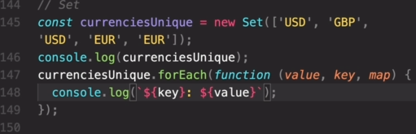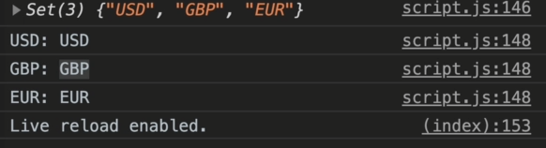

In sets the value and key variables contains the same thing since in sets neither there is a positional index nor any key.

CallBack Function:

In forEach() the function we define inside the forEach() parameter is called a callback function.

A callback function is a function passed into another function as an argument, which is then invoked inside the outer function to complete some kind of routine or action.

Here is a quick example:

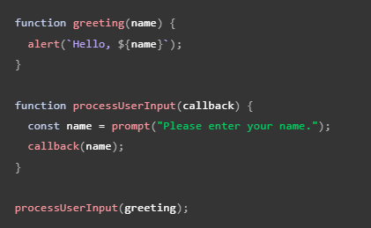

The above example is a [synchronous](https://developer.mozilla.org/en-US/docs/Glossary/Synchronous) callback, as it is executed immediately.

Note, however, that callbacks are often used to continue code execution after an [asynchronous](https://developer.mozilla.org/en-US/docs/Glossary/Asynchronous) operation has completed — these are called asynchronous callbacks. A good example is the callback functions executed inside a [.then()](https://developer.mozilla.org/en-US/docs/Web/JavaScript/Reference/Global_Objects/Promise/then) block chained onto the end of a promise after that promise fulfills or rejects. This structure is used in many modern web APIs, such as [fetch()](https://developer.mozilla.org/en-US/docs/Web/API/fetch).

Element.insertAdjacentHTML() - <https://developer.mozilla.org/en-US/docs/Web/API/Element/insertAdjacentHTML>

Important Array Methods:

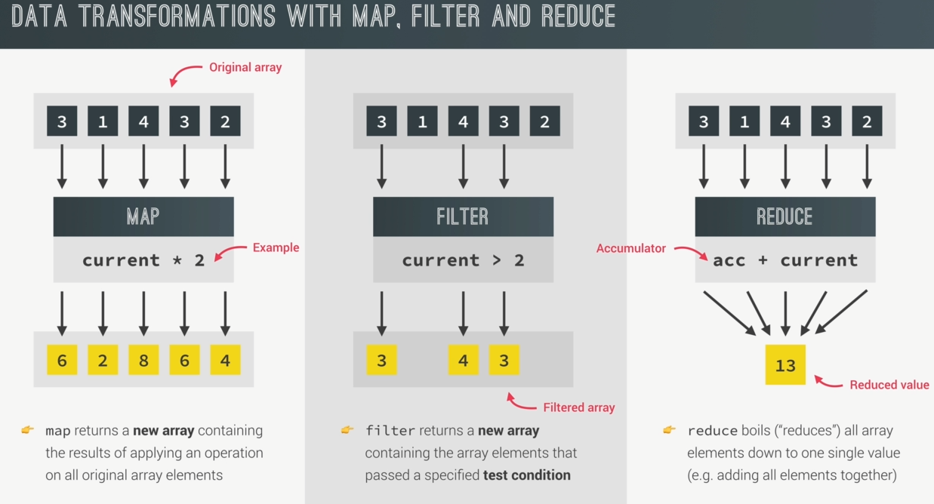

map():

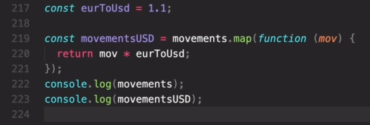  
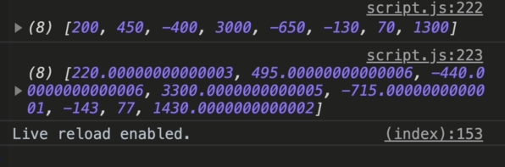

Similar to forEach(), map() also passes the current element of the array, the index and the entire array itself in respective order in the callBack() –

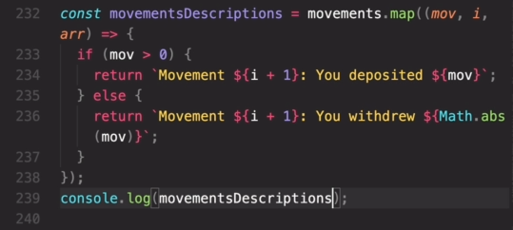  
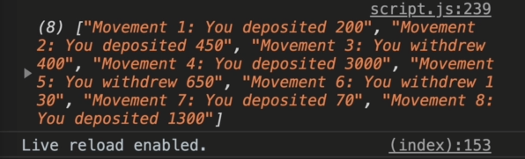

filter():

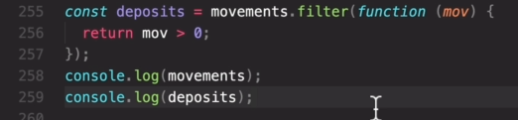  
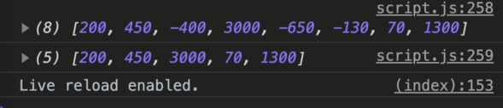

filter() also passes the current element of the array, the index and the entire array itself in respective order in the callBack() –

reduce():

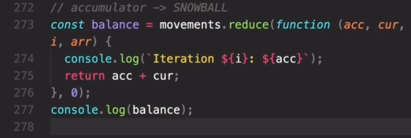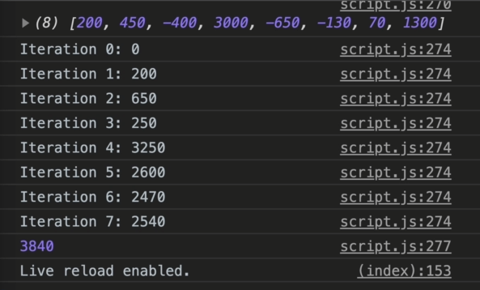

Values passed in reduce()’s callback() is different from the other functions.

.reduce(function(accumulator, currentValue, iterator, array){},initialValueOfAccumulator)   
reduce() passes the accumulator, current element of the array, the index and the entire array itself in respective order in the callBack().

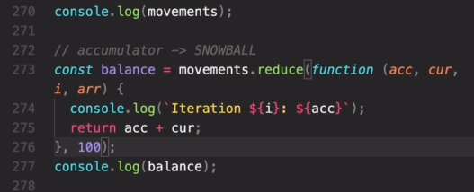  
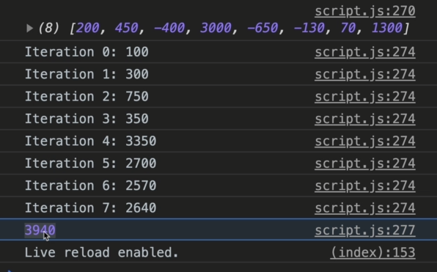

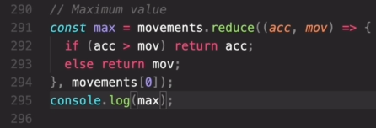  


Chaining Methods:

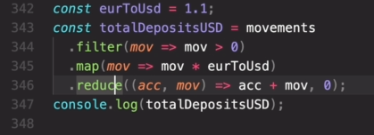  


find():

it is similar to filter() but difference is filter() returns an array of all the elements that satisfies its condition but find() only returns a single element i.e. the first element which satisfies its condition.

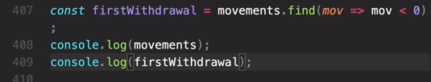  
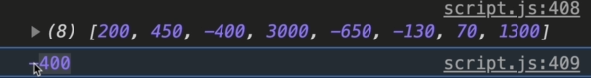

findIndex():

similar to find() only difference is it returns the index of the matching element and not the element itself.

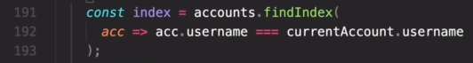  


includes():

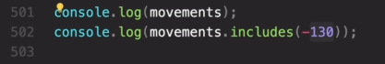  
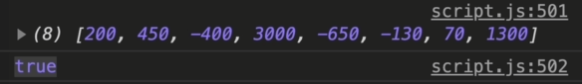

some():

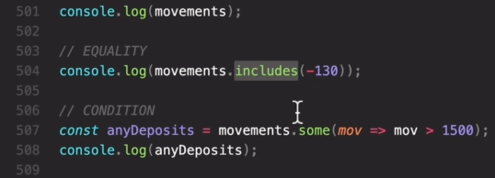  
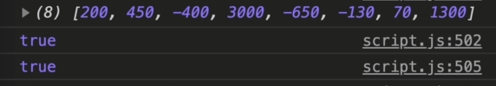

every():

returns true only if all the elements of the array satisfies its condition.  
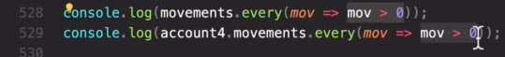  
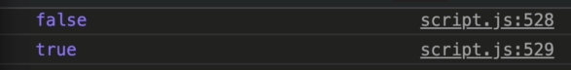

Defining callBack() separately,

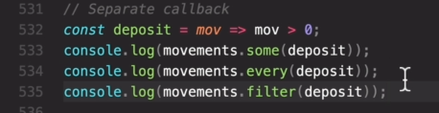  
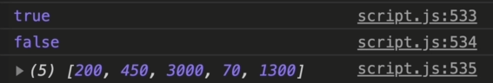

flat():

used in array of arrays i.e. nested array

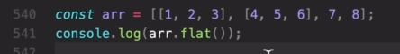  
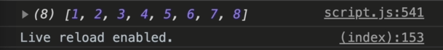

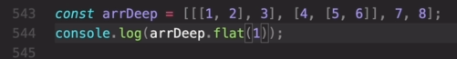  


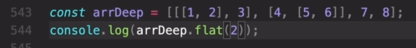  


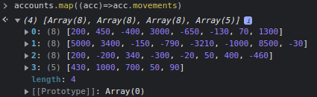

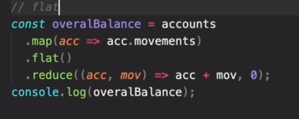  


flatMap():

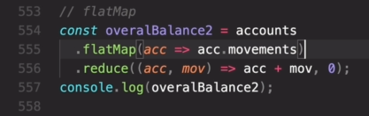  


sort():

sort() mutates the original array.

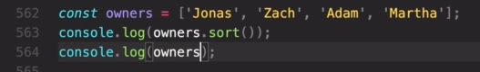  
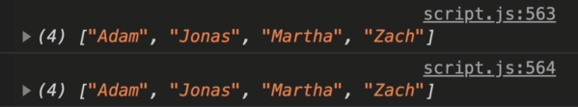

Sort() only sorts does the sorting based on string by default

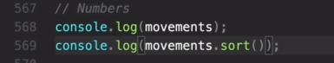  
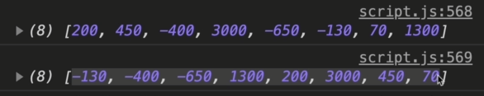

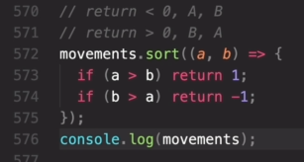  


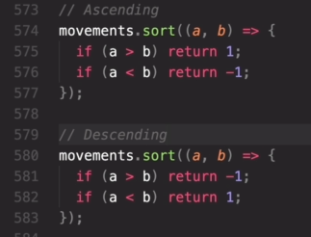

‘a’ and ‘b’ represents two consecutive elements in an array, if we want ‘a’ to be printed before ‘b’ we return something less than 0 else return something greater then 0. In above condition (line 575) if (a>b) then we want ‘b’ to be printed before ‘a’ so we return 1(something greater then 0).

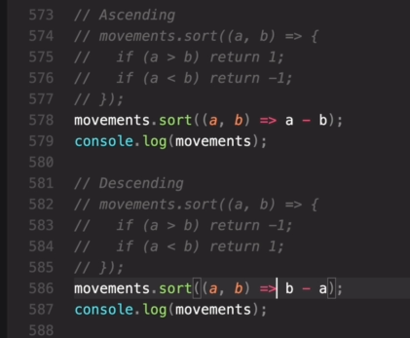

Methods used to fill array :-

fill():

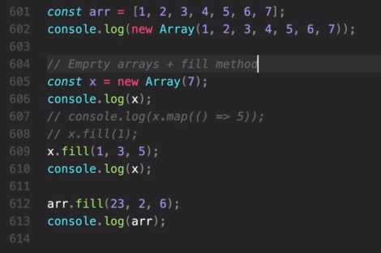  
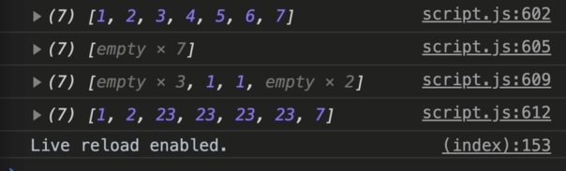

**Passing only one element in new Array() creates an empty array of size equal to that element.

Array.from():

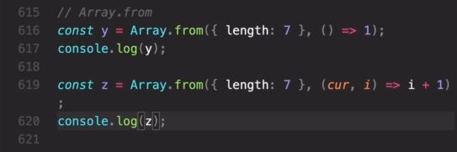  
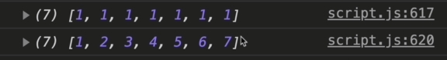

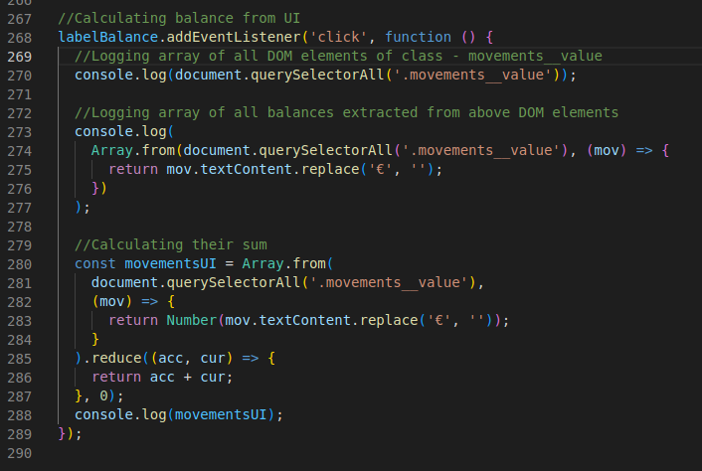  
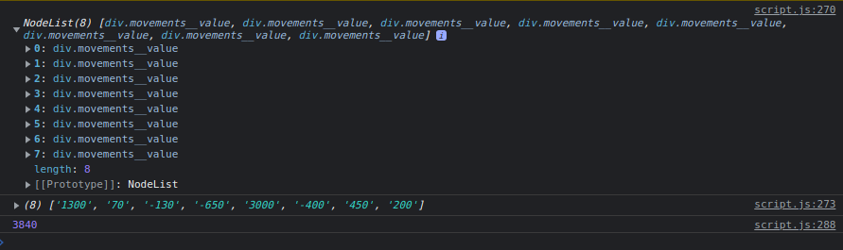

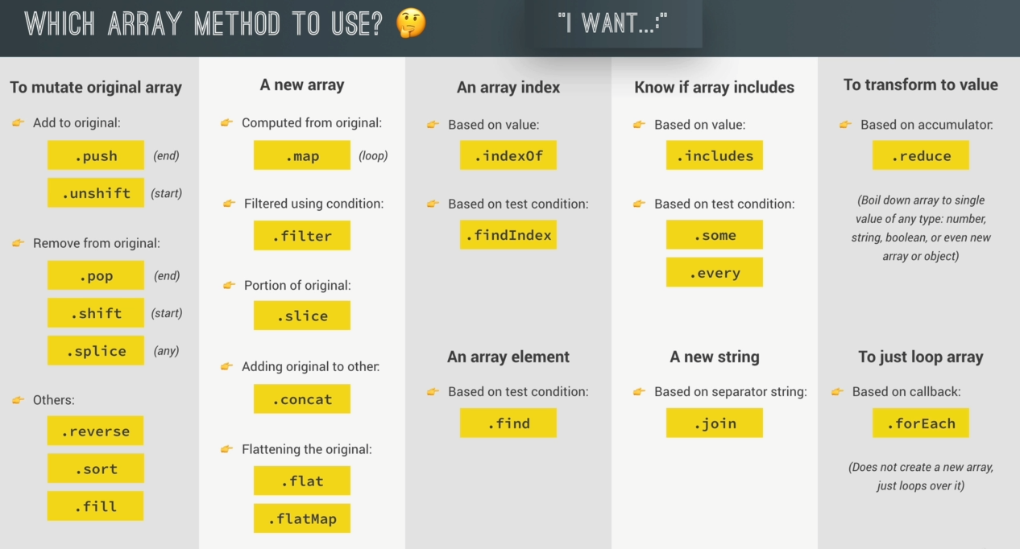

Number related methods:

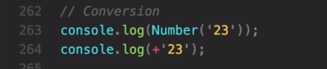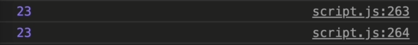

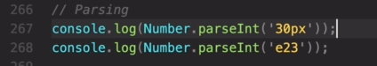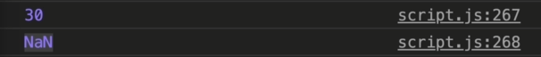

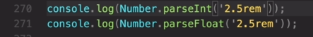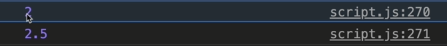

Method to check if any value is a number or not -

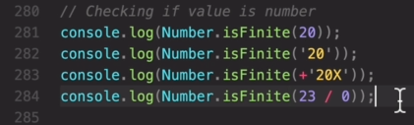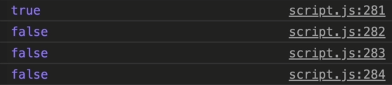

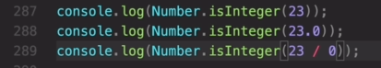  
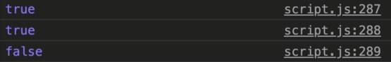

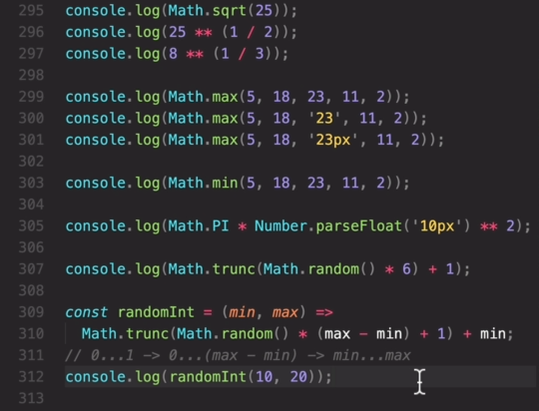  
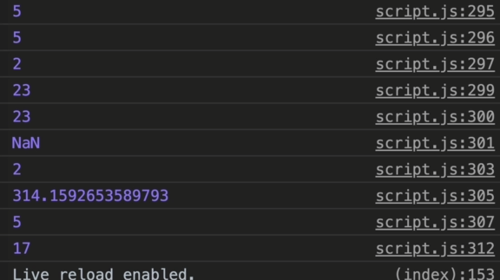

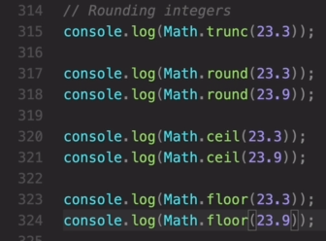  
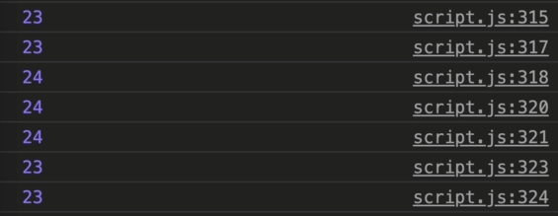

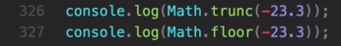  
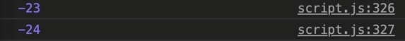

BigInt:

BigInt is represented by ‘n’ –

  


Date:

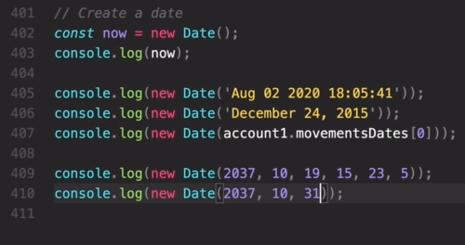  
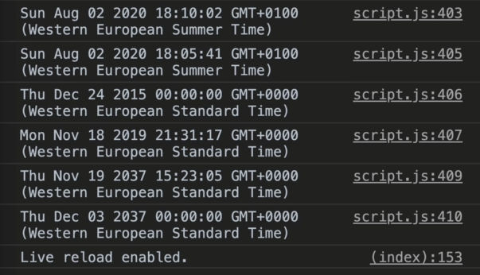

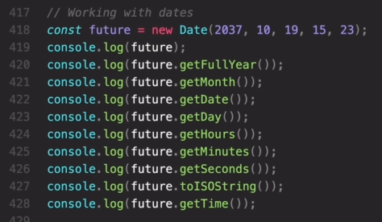  
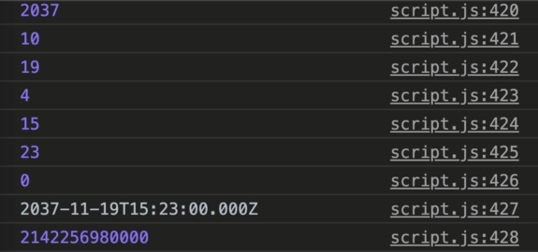

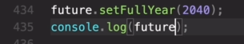

Advanced DOM Manipulation –

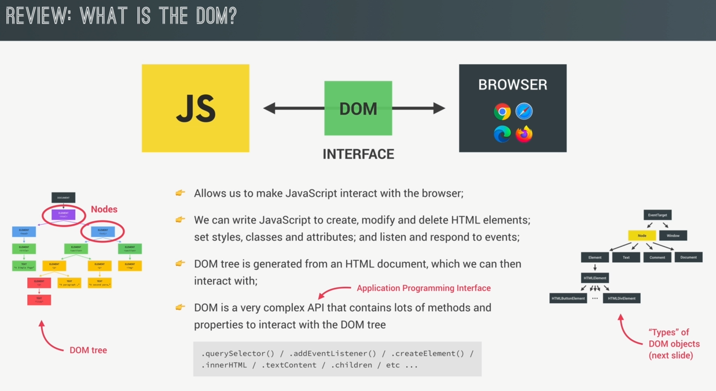

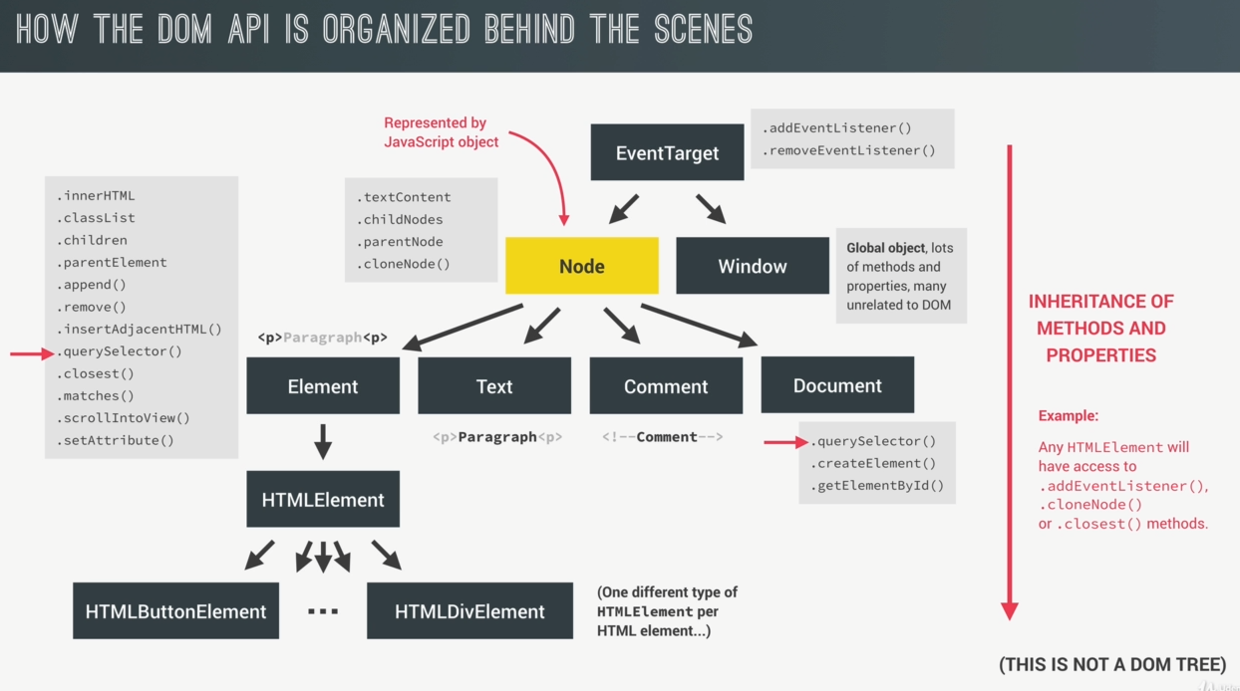

The DOM API is broken up into these types of Node i.e. ElementNode, TextNode …. Etc. Each Node has access to different properties and methods like .innerHTML, .addEventListner etc. and even inherit more properties and methods from its parent nodes.

We usually listen to events by calling . addEventListner on a Element or a Document, it works because there is a special Node type called EventTarget which is a parent of both the Node type an Window node type. And because of inheritance we can call .addEventListner on any Node in the DOM API

Selecting DOM Elements:

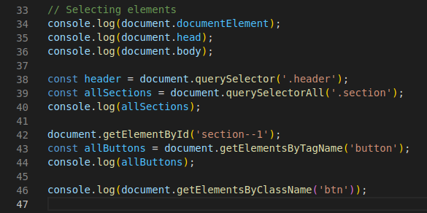  
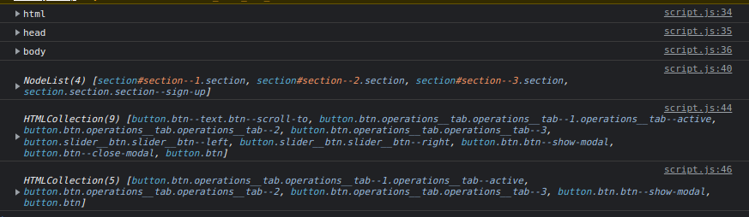

querySelectorAll() returns a NodeList where as getElementByTagName() or getElementByClassName() returns a HTMLCollection. HTMLCollection is a live collection wherein if any DOM element is deleted or changes this will also get updated whereas the querySelectorAll() will remain the same as it was when it was created.

document.createElement() – used to create a DOM element. This method does not inserts the created DOM element anywhere, we have to manually insert it.

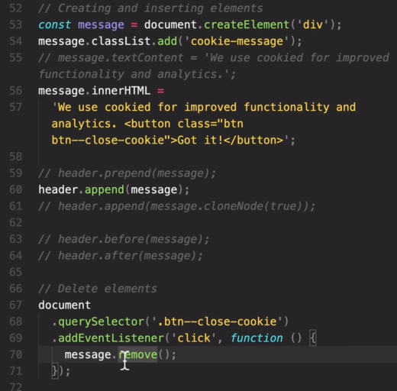

Element.classList returns all the class attributes of the element as a live DOMTokenList. Although the classList property itself is read-only, you can modify its associated DOMTokenList using the add(), remove(), replace(), and toggle() methods.

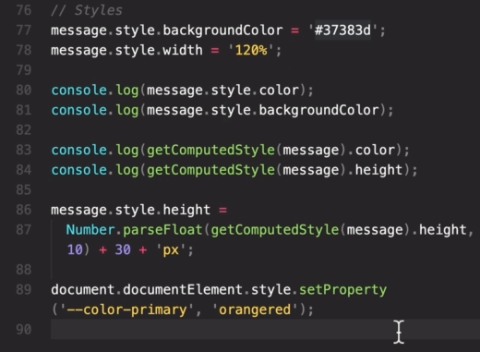  
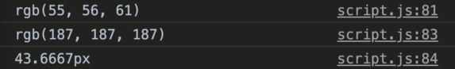

The .getComputedStyle() method returns an object containing the values of all CSS properties of an element, from there we can choose a particular property as we have done above.

Line 89 – in .css file we have defined some variables containing values of colour in root element, those variables are manipulated here.  
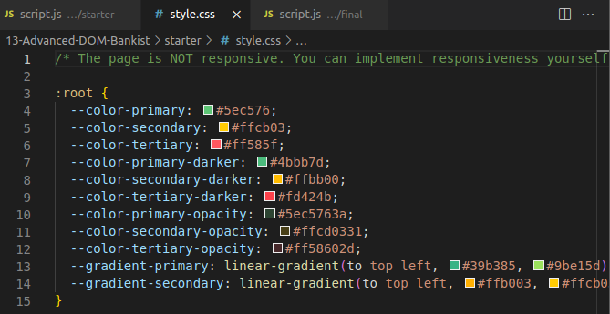

**Attributes and properties**

When the browser loads the page, it “reads” (another word: “parses”) the HTML and generates DOM objects from it. For element nodes, most standard HTML attributes automatically become properties of DOM objects.

For instance, if the tag is <body id="page">,(here ‘body’ is the element and ‘id’ is the attribute) then the browser creates DOM object for ‘body’ and DOM property ‘id’ has body.id="page".

But the attribute-property mapping is not one-to-one!

In HTML, tags may have attributes. When the browser parses the HTML to create DOM objects for tags, it recognizes *standard* attributes and creates DOM properties from them.

So when an element has id or another *standard* attribute, the corresponding property gets created. But that doesn’t happen if the attribute is non-standard.

For instance:

<body id="test" something="non-standard">

<script>

alert(document.body.id); // test

// non-standard attribute does not yield a property

alert(document.body.something); // undefined

</script>

</body>

To get non-standard attributes we need to use .getAttribute()

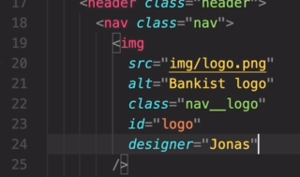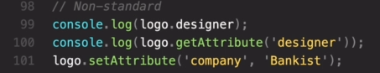  
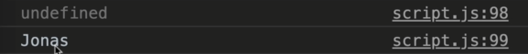

Element.setAttribute(‘attributeName’, ‘attributeValue’) - Sets the value of an attribute on the specified element. If the attribute already exists, the value is updated; otherwise a new attribute is added with the specified name and value.

The Element method removeAttribute(‘attributeName’) removes the attribute with the specified name from the element.

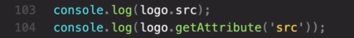  
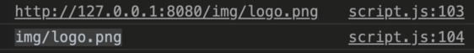

Data Attributes:

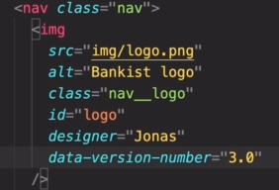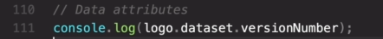  


data-* attributes allow us to store extra information on standard, semantic HTML elements without other hacks such as non-standard attributes, or extra properties on DOM.  
The syntax is simple. Any attribute on any element whose attribute name starts with data- is a data attribute. Say you have an article and you want to store some extra information that doesn't have any visual representation. Just use data attributes for that:

<article

id="electric-cars"

data-columns="3"

data-index-number="12314"

data-parent="cars">

…

</article

Reading the values of these attributes out in JavaScript is also very simple. You could use getAttribute() with their full HTML name to read them or you can read out via a dataset property.

To get a data attribute through the dataset object, get the property by the part of the attribute name after data- (note that dashes are converted to camelCase).

const article = document.querySelector("#electric-cars");

// The following would also work:

// const article = document.getElementById("electric-cars")

article.dataset.columns; // "3"

article.dataset.indexNumber; // "12314"

article.dataset.parent; // "cars"

**Note – in HTML the data property is defined as ‘index-number’ but to get the value from dataset property we define it as ‘indexNumber’

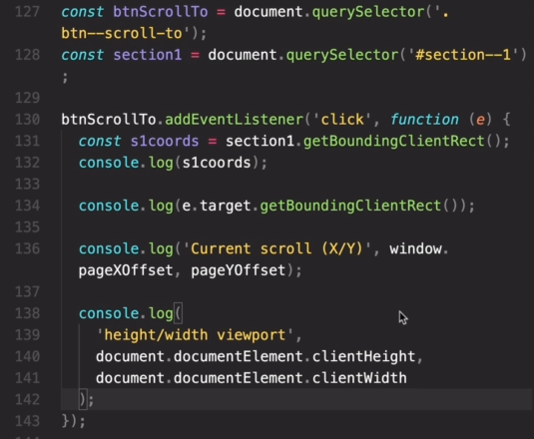

The Element.getBoundingClientRect() method returns a DOMRect object providing information about the size of an element and its position relative to the viewport.  
The returned value is a DOMRect object which is the smallest rectangle which contains the entire element, including its padding and border-width. The left, top, right, bottom, x, y, width, and height properties describe the position and size of the overall rectangle in pixels. Properties other than width and height are relative to the top-left of the viewport.

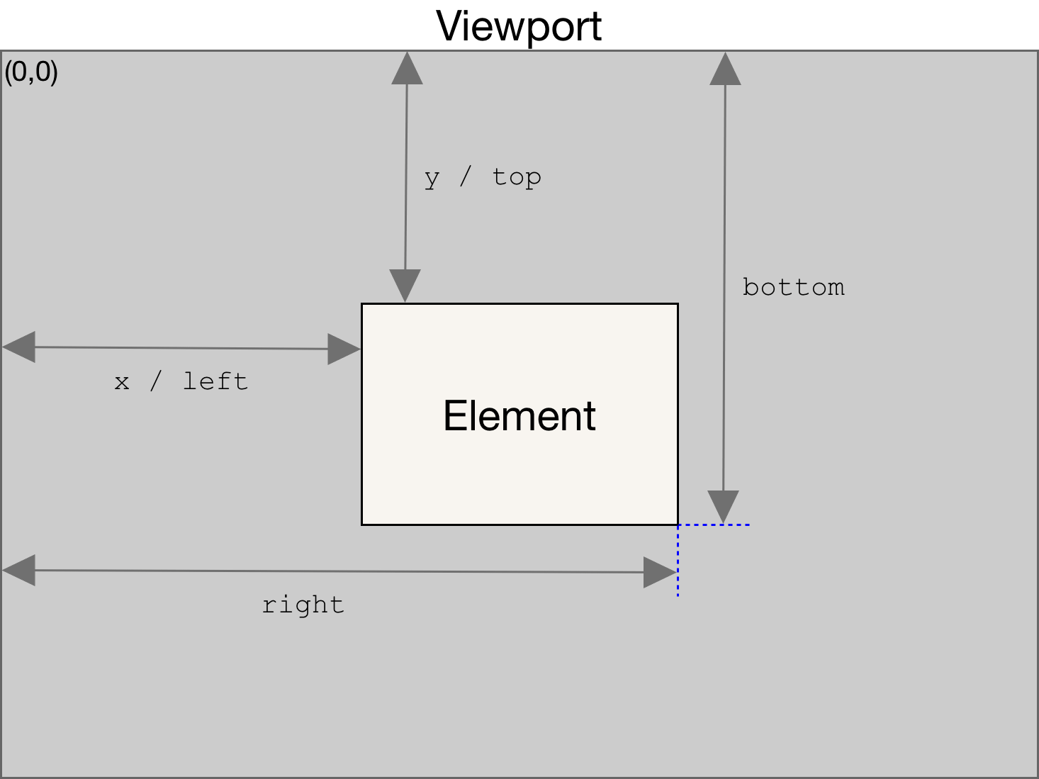

.removeEventListner():

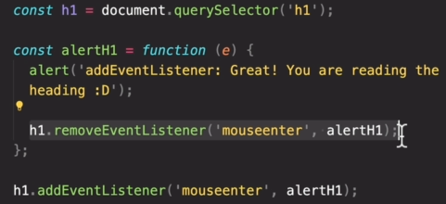



Js Event Bubbling and Capturing:

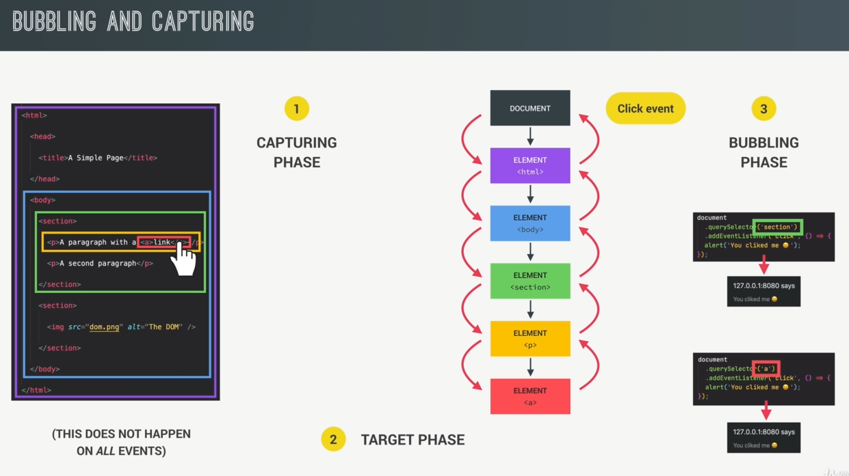

When a click happens on the <a> element, the DOM generates a click event at the root of the document i.e. at the top of the DOM tree and from there the CAPTURING Phase begins where the event then travels all the way to the target element. As it travels it will pass through all parent elements of the target element.  
Once it reaches the target element the target phase begins where events can be handled right at the target (which we do using addEventlistner). So the addEventListner executes in TARGET Phase and in Bubbling phase.  
After reaching the target the event then again travels all the way up to the document root again in the BUBBLING Phase and as it travels it will again pass through all parent elements of the target element(only parent element not the sibling element). In BUBBLING phase when it travels through the parent element it is as if the event has happened in the parent itself through which it is passing. What this means is the if we attach the same EventListner to any of the parent element then we will get the same function for the parent element also i.e. the event would be handled on every parent having the same EventListner

**All event does not have a CAPTURING phase and BUBBLING Phase.

In below code if we click on ‘nav__link’, the other two eventlisteners also execute.

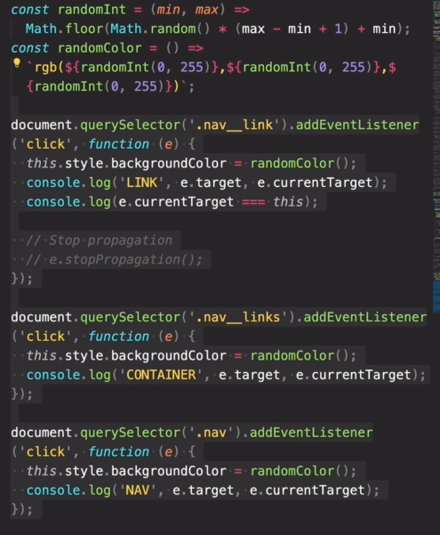

addEventListner listens to event only in TARGET Phase and in Bubbling phase and not in CAPTURING phase. But we can change that by adding a ‘true’ value as the third parameter in addEventListner i.e. addEventListner(‘click’, function(){}, true)

Event Delegation:

Event Delegation is basically a pattern to handle events efficiently. Instead of adding an event listener to each and every similar element, we can add an event listener to a parent element and call an event on a particular target using the .target property of the event object.

In below code we have performed event delegation by adding the ‘eventListner’ to the parent ‘nav__links’ and not to all the child ‘nav__link’ elements. When the event is triggered in child element it propagates to the parent element where we handle the event. First we check if target element where the event is triggered is 'nav__link', we access the target element (i.e. from where the event has generated) using ‘event.target’

Then we get the id of the particular 'nav__link' from href property which is defined in the html page. And then get the coordinates of that element where we need to scroll to and apply scroll functionality.

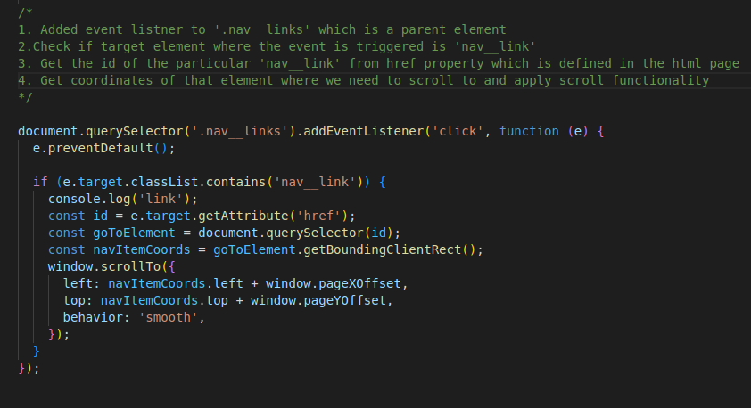

DOM Traversing:

Selecting Child elements from Parent element -

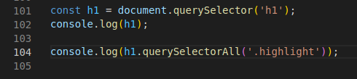

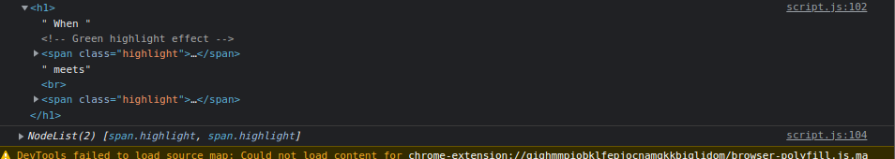

h1.querySelectorAll(‘.highlight’) will only return the element with class = ‘highlight’ which are child elements of h1 element.   
querySelector() and querySelectorAll() only selects child elements when used with an element.

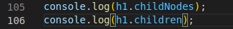  


.childNodes return all child nodes whereas .children returns all child element.

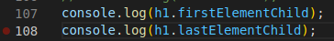  
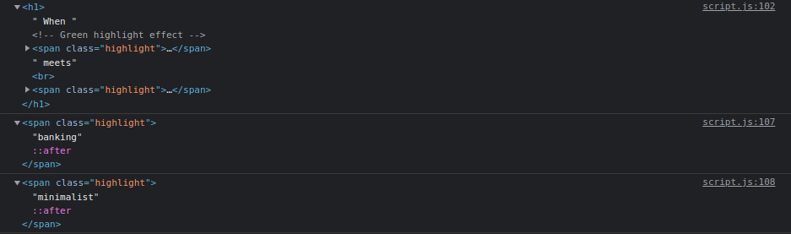

Selecting Parent element from Child element-

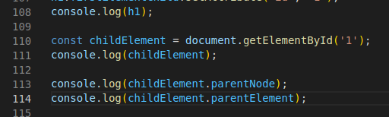  
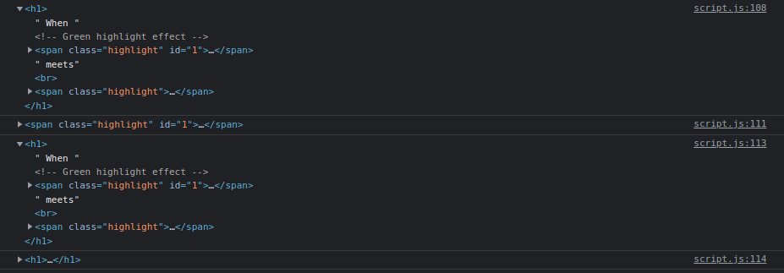

Here in above code variable ‘childElement’ is a child element of h1.  
both .parentNode and .parentElement returns h1 as there is only one element.

.closest():

It returns the closest ancestor/parent Element or itself, which matches the selectors. If there are no such element, null.

  
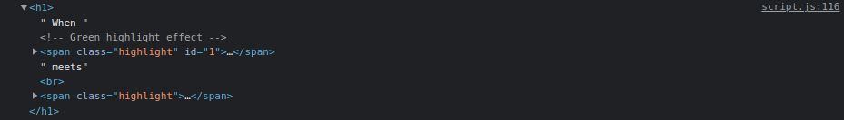

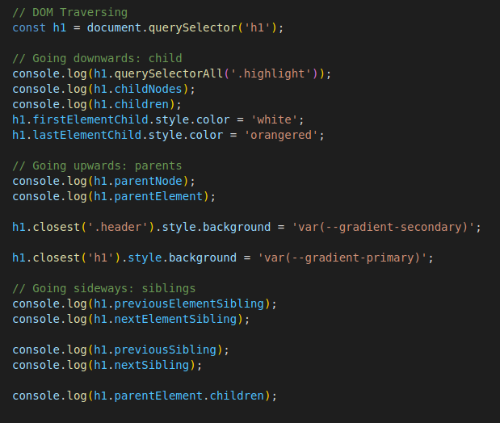

Passing Arguments to Event Handler:

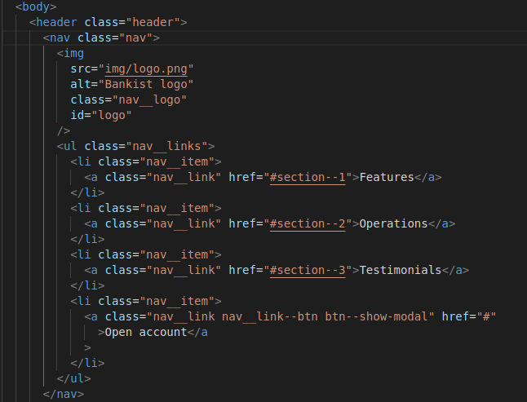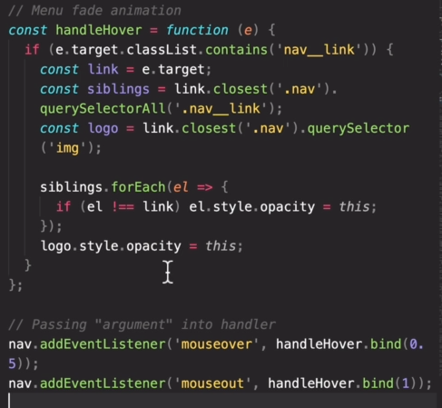  
const nav = document.querySelector('.nav');

Using the bind() we pass the ‘event’ variable by default and the 1st argument in bind() is the ‘this’ keyword.

Sticky Navigation:

Using scroll event –

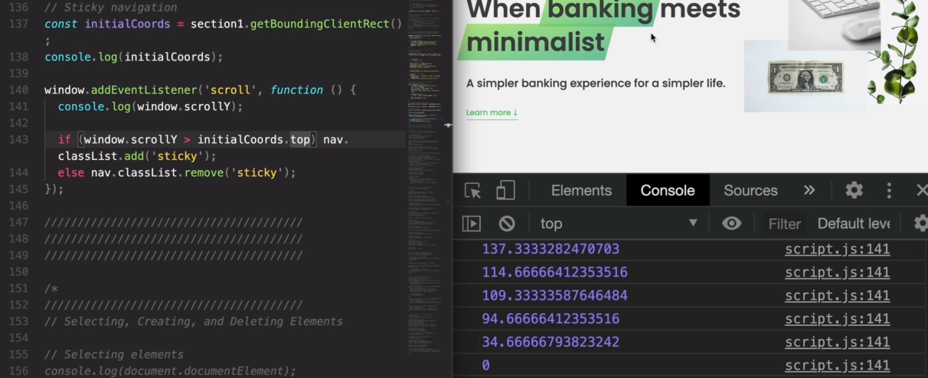

Scroll event should be avoided as much as possible because every time the user scrolls the scroll event is fired which is bad for performance.

Using IntersectionObserver API -

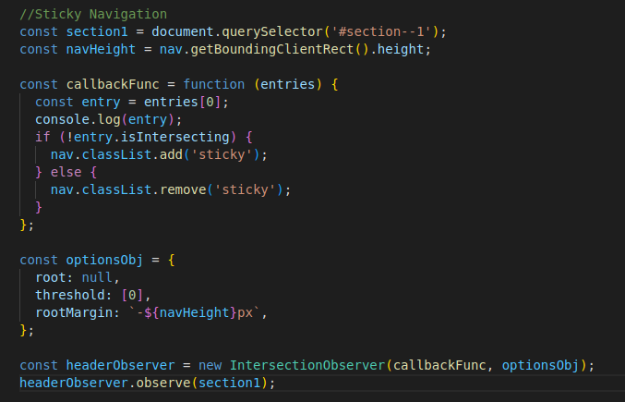

The Intersection Observer API provides a way to asynchronously observe changes in the intersection of a target element with an parent element or with a top-level document's viewport. We need to create an IntersectionObserver object and pass a callback function and an object to it.

The object will contain parameters like the root, threshold and rootMargin.  
root - The element that is used as the viewport for checking visibility of the target i.e. the element the target is intersecting. Must be the parent of the target. Defaults to the browser viewport if not specified or if null.

threshold - Either a single number or an array of numbers which indicate at what percentage of the target's visibility/intersection the observer's callback should be executed. If you only want to detect when visibility passes the 50% mark, you can use a value of 0.5. If you want the callback to run every time visibility passes another 25%, you would specify the array [0, 0.25, 0.5, 0.75, 1]. The default is 0.

rootMargin - Margin around the root.The values can be percentages. This set of values serves to grow or shrink each side of the root element's bounding box before computing intersections. Defaults to all zeros.

The callback function will get executed each time the target element intersects the root element (or the viewport if root is null) at the threshold that we defined. So in above code whenever the section1 element is intersecting the viewport at 0% the callback function will be called. The callback function gets called with two arguments (entries, observer Object).

The entries gives us an array of IntersectionObserverEntry object and this object has the following

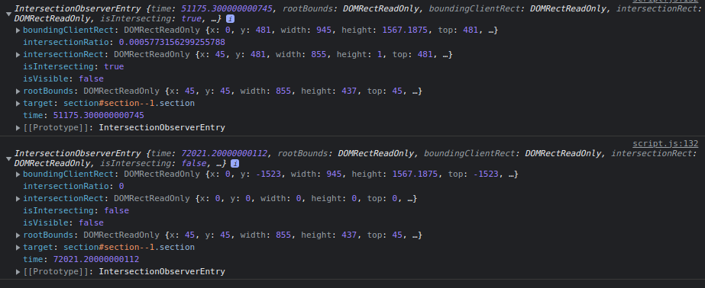

Here the IntersectionRatio is 0 because the threshold in above code is 0, the callback function is only executed when IntersectionRatio matches the defined threshold value. The callback function is called twice so there are two IntersectionObserverEntry obj printed 1st time when we are entering into the section1 element and 2nd time when we are leaving it. In both scenarios the IntersectionRatio is 0.

Revealing Sections as we scroll –

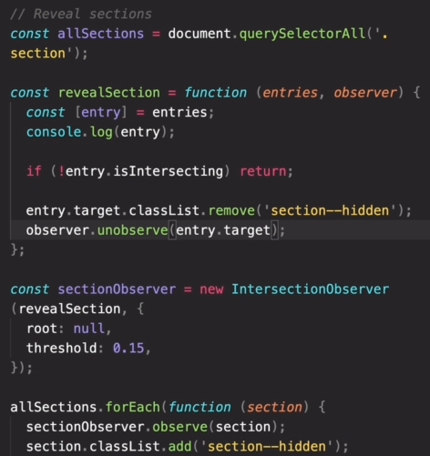

Lazy Loading if Images:

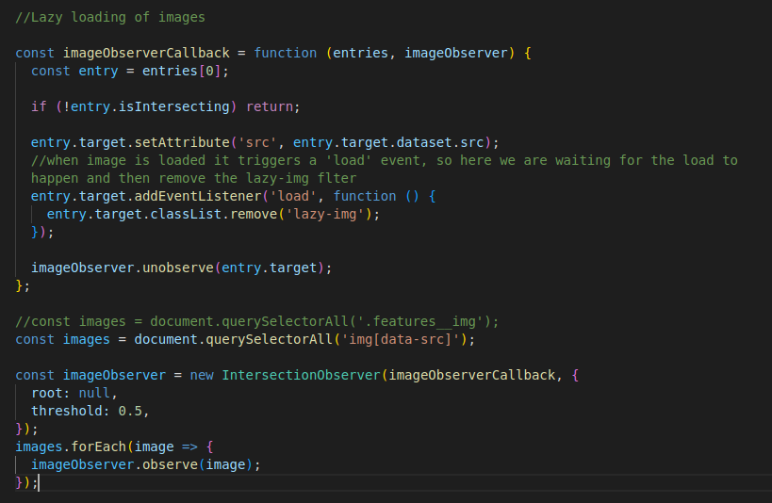

const images = document.querySelectorAll('img[data-src]'); --- selecting all img elements under document which has an attribute ‘data-src’

DOM Lifecycle Events:

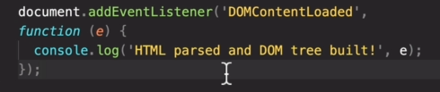

DOMContentLoaded only gets executed after all the HTML is parsed and DOM tree is build

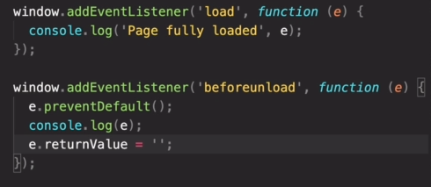

The ‘load’ event is fired when the whole page has loaded, including all dependent resources such as stylesheets, scripts, iframes, and images. This is in contrast to DOMContentLoaded, which is fired as soon as the page DOM has been loaded, without waiting for resources to finish loading.

The ‘beforeunload’ event enables a web page to trigger a confirmation dialog asking the user if they really want to leave the page. If the user confirms, the browser navigates to the new page, otherwise it cancels the navigation.

Different ways of loading script:

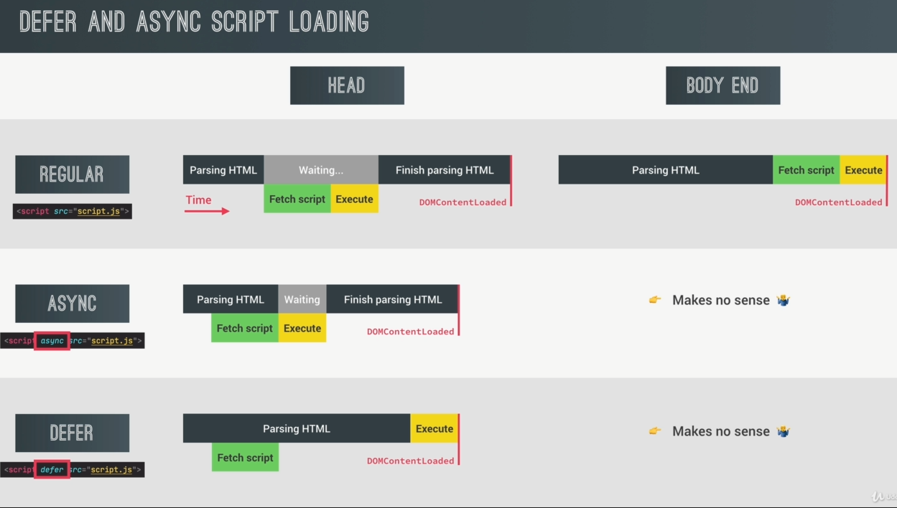

In defer script loading technique the script is loaded at the same time as the HTML is parsed but it is executes only after the HTML is parsed fully not like async script loading technique where the script is executed as soon as it is loaded during which the parsing of HTML is paused .   
(parsing HTML meaning creating DOM tree)

Using async or defer at the end of the body tag makes no sense as script will be loaded and executed only after the HTML is parsed completely.

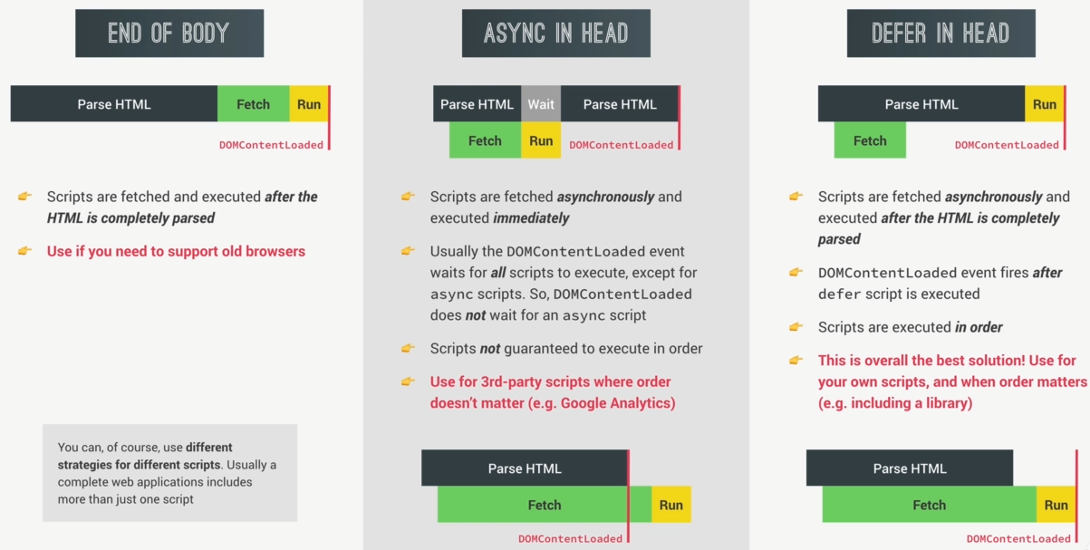

OOP in JavaScript:

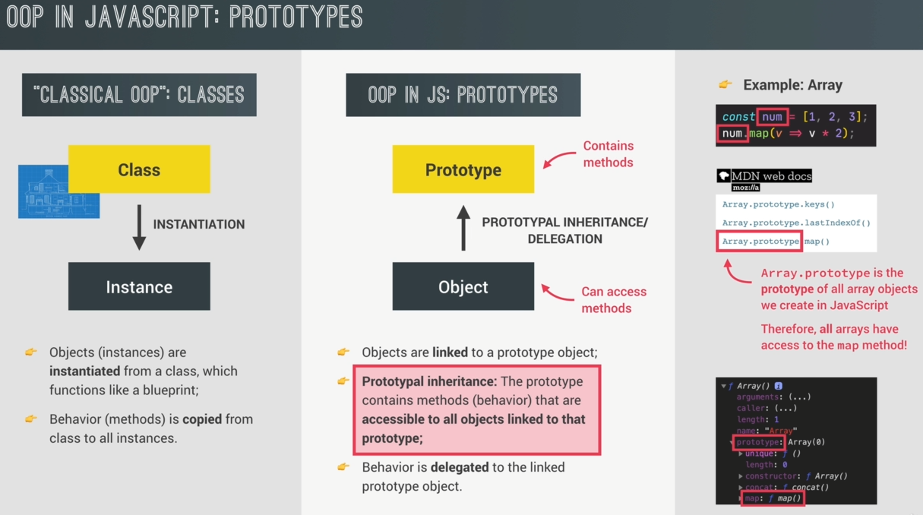

In Js there are ‘prototypes’, all objects in Js are linked to a certain prototype object i.e. we can say each object has a prototype. The ‘prototype objects’ contains all the methods and properties that all objects linked to that prototype can access and use, this behaviour is called Prototypal Inheritance.   
Prototypal Inheritance means that all objects that are linked to a certain prototype object can use the methods and properties that are defined on that prototype i.e. objects inherits the methods and properties from the prototype.   
This inheritance is different from Java inheritance where one class inherits from another class but here it is an instance inheriting from a class.

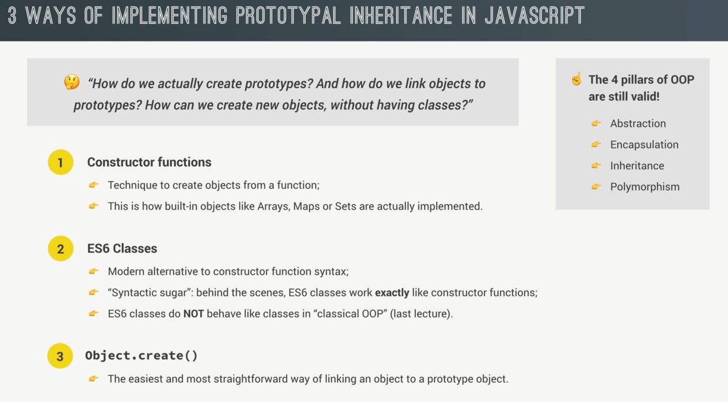

Creating Constructor Function:

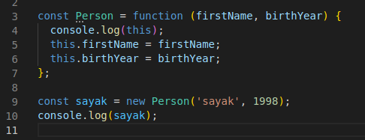

When a function is called with the ‘new’ keyword, the function will be used as a constructor. ‘new’ will do the following things:

* Creates a blank, plain JavaScript object. For convenience, let's call it newInstance.
* Points newInstance's [[Prototype]] to the constructor function's prototype property, if the prototype is an Object. Otherwise, newInstance stays as a plain object with Object.prototype as its [[Prototype]].

Note: Properties/objects added to the constructor function's prototype property are therefore accessible to all instances created from the constructor function.

* Executes the constructor function with the given arguments, binding newInstance as the this context (i.e. all references to this in the constructor function now refer to newInstance).
* If the constructor function returns a non-primitive, this return value becomes the result of the whole new expression. Otherwise, if the constructor function doesn't return anything or returns a primitive, newInstance is returned instead. (Normally constructors don't return a value, but they can choose to do so to override the normal object creation process.)

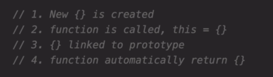

Function Prototype:

Each and every function in Js automatically has a property called Prototype, evert object that is created using a certain constructor function will get access to all the methods and properties that we define on the constructor’s prototype property.

The prototype data property of a Function instance is used when the function is used as a constructor with the new operator. It will become the new object's prototype. When a function is called with new, the constructor's prototype property will become the resulting object's prototype.

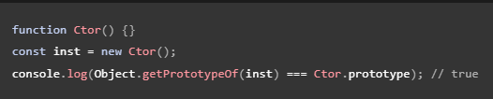

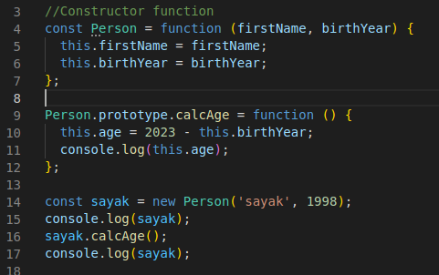  


The prototype of object ‘sayak’ or any other object created using constructor function Person is Person.prototype . We can access the prototype of an object using the .__proto__ property of an object, this is a special property which every object has.

  
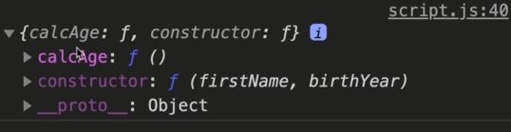

The prototype of the Jonas object is actually the Prototype property of the constructor function.

Basically, .__proto__ returns the prototype of the object which is actually the prototype property of the constructor function. The .__proto__ is set to the constructor function’s prototype property when we call the constructor function using the ‘new’ keyword during object creation. We can confirm this statement from below code.

Person.prototype is actually prototype of the linked objects and not the prototype of constructor function Person

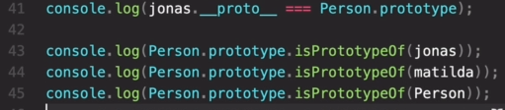  
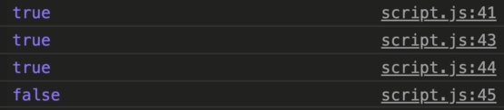

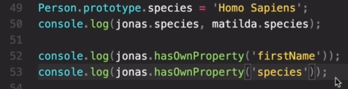 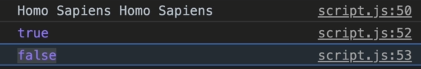

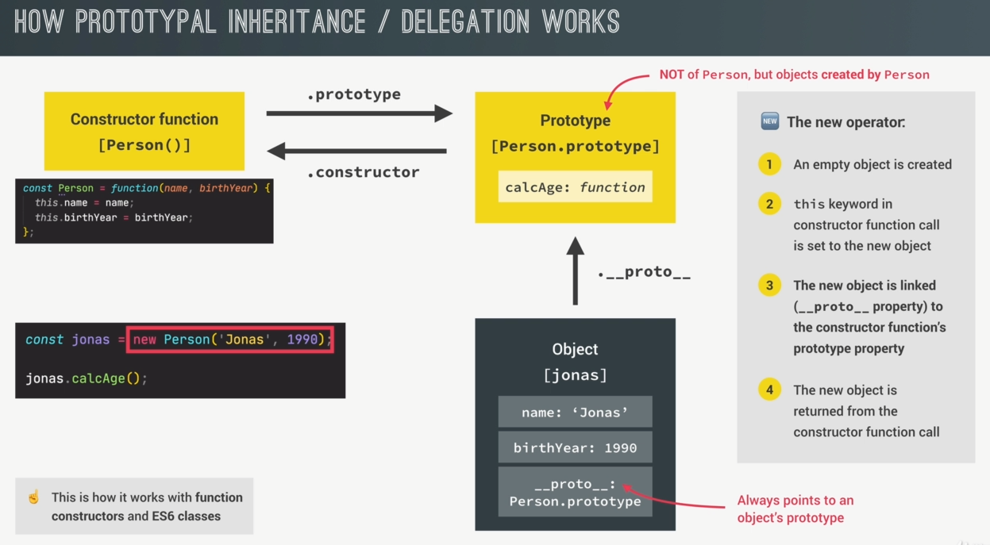

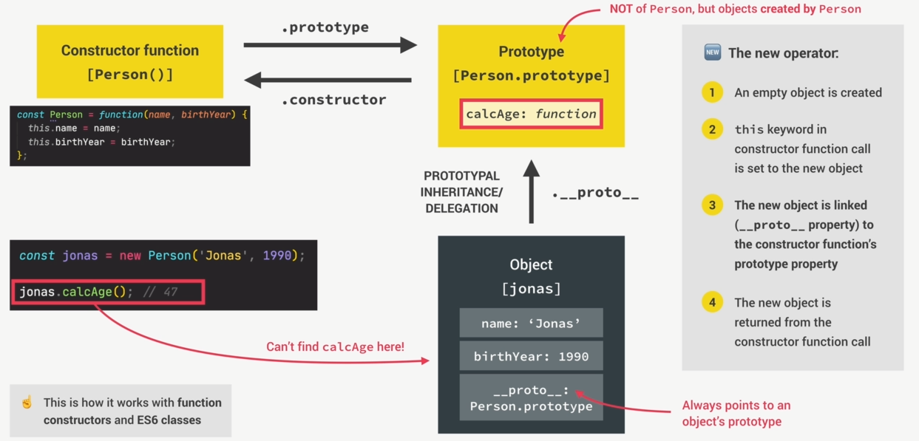

When jonas.calcAge() is called Js first tries to find it in the jonas object itself, when it doesn’t find it there Js starts looking for it in its prototype. this behaviour is called Prototypal Inheritance/ Delegation.

The Prototype Chain:

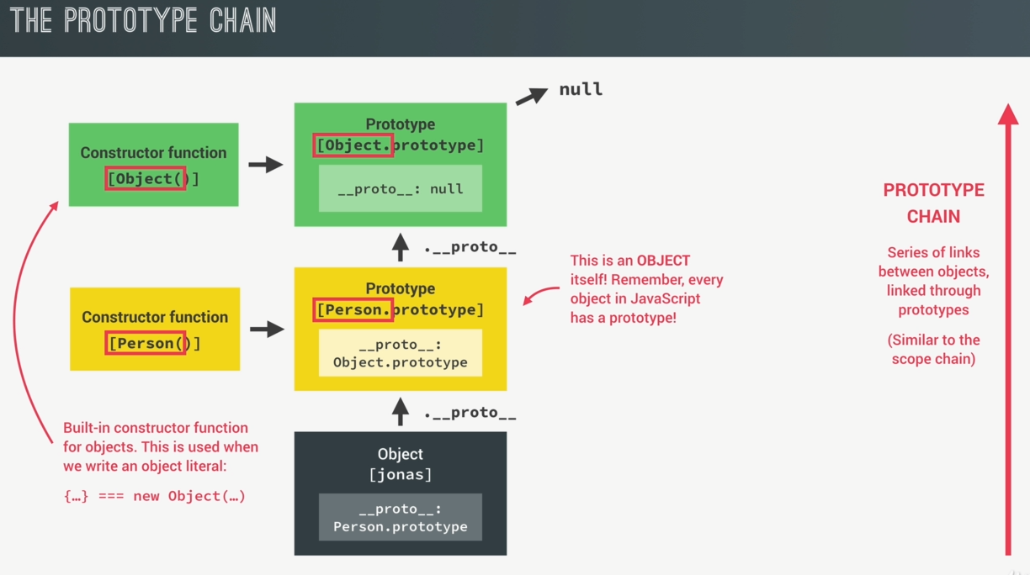

How hasOwnProperty is accessed which is defined in the Object.prototype

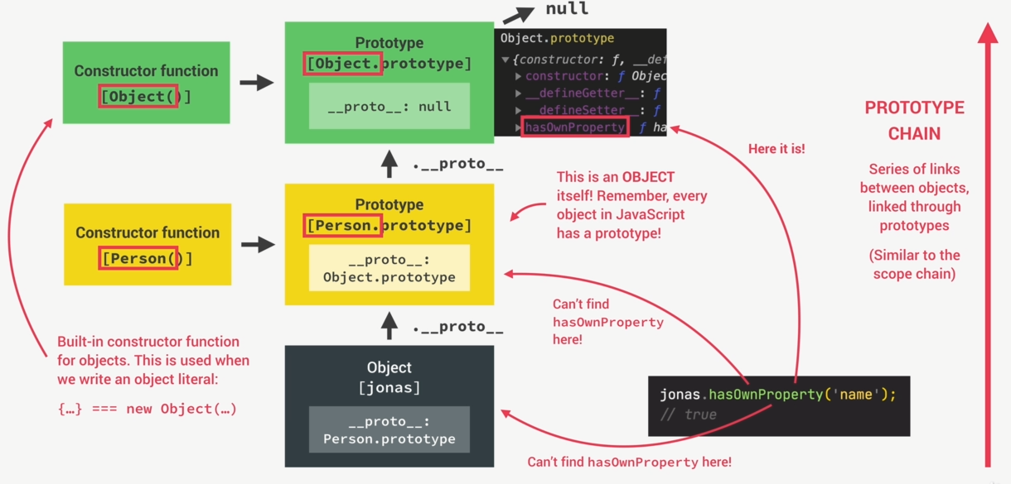

ES6 Classes:

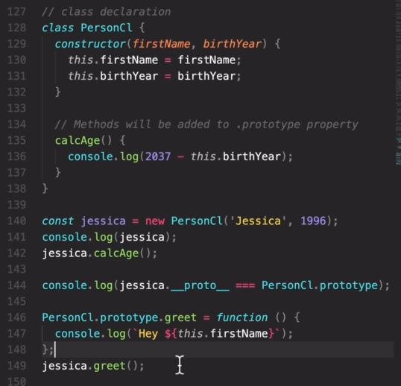  
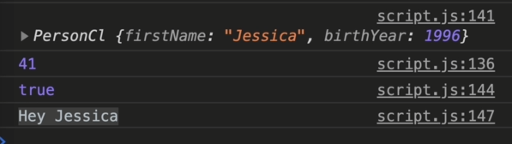

Getters and Setters:

In Object –

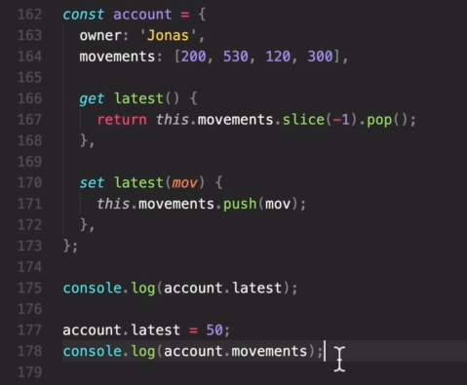  
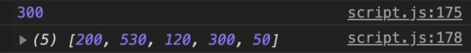

In Classes also it works similarly.

Static Methods:

In Constructor Function –

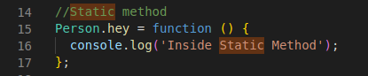  
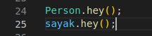 

Because the ‘hey()’ is not defined inside Person.prototype property it is only accessible by the Constructor Function object itself and not by other Objects that are created using this Constructor Function.

In ES6 Class –

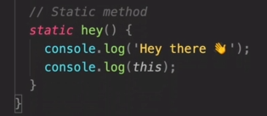

Object.create():

The Object.create() method creates a new object, using an existing object as the prototype of the newly created object. In below code it basically sets the ._proto__ property of ‘steven’ to PersonProto object.

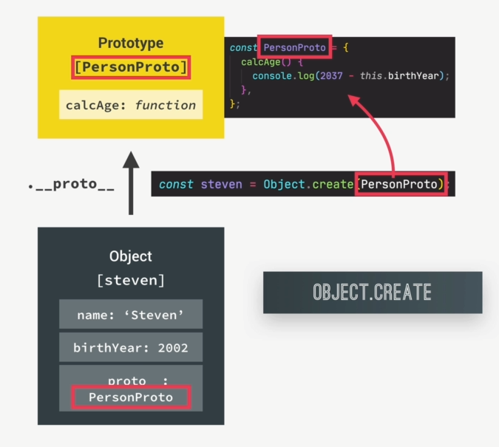

  


Inheritance in Js using Constructor Functions:

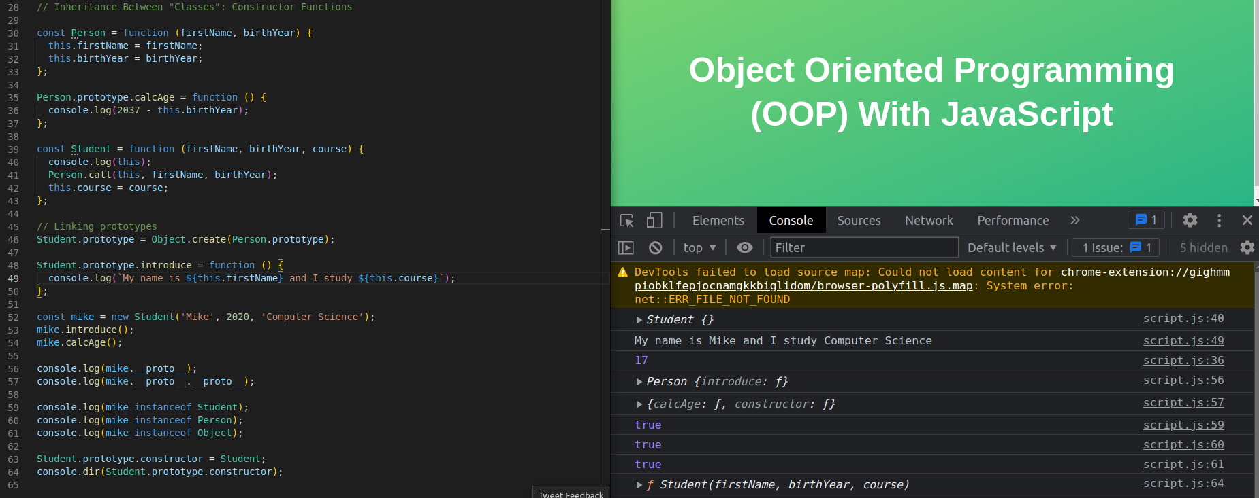

When we are calling the Person() in line 41 we need to set the ‘this’ keyword so we use .call() to set the ‘this’ keyword which will be used in the Person function.

In order to make the Student class the child class of Person class so that it can inherit all methods and properties of Person class we set the .__proto__ property of Student.prototype to the Person.prototype using Object.create() as done in line 46.

Line 54 – ‘mike’ instance which is an object of Student has access to .calcAge() because of Delegation and Inheritance. 1st Js searches for calcAge() inside ‘mike’ object then it searches mike’s __proto__ property which is Student.prototype , it doesn’t find it there also so it looks for it in the Student.prototype’s __proto__ property i.e. Person.prototype which is set in line 46.

